SUPPLEMENTARY MATERIAL

- SEARCHES

First Search: 12/02/2024 Last search: 01/12/2024

PUBMED-MEDLINE
Search query:
((("Gynecology"[Mesh]) OR ("Obstetrics"[Mesh])) OR ((((gynecology) OR (gynaecology)) OR ("obstetrics and gynecology")) OR ("obstetrics and gynaecology"))) AND (((((laparoscopy) OR ("laparoscopic surgery")) OR ("Laparoscopy"[Mesh])) AND ((hysterectomy) OR ("Hysterectomy"[Mesh]))) OR ("laparoscopic hysterectomy"))

Results 4850

SCOPUS
Search query:
( ( TITLE-ABS-KEY ( gynecology ) ) OR ( TITLE-ABS-KEY ( gynaecology ) ) OR ( TITLE-ABS-KEY ( obstetrics ) ) ) AND ( ( ( ( TITLE-ABS-KEY ( laparoscopy ) ) OR ( TITLE-ABS-KEY ( "laparoscopic surgery" ) ) ) AND ( TITLE-ABS-KEY ( hysterectomy ) ) ) OR ( TITLE-ABS-KEY ( "laparoscopic hysterectomy" ) ) )

Results 1867

COCHRANE LIBRARY
Search query:
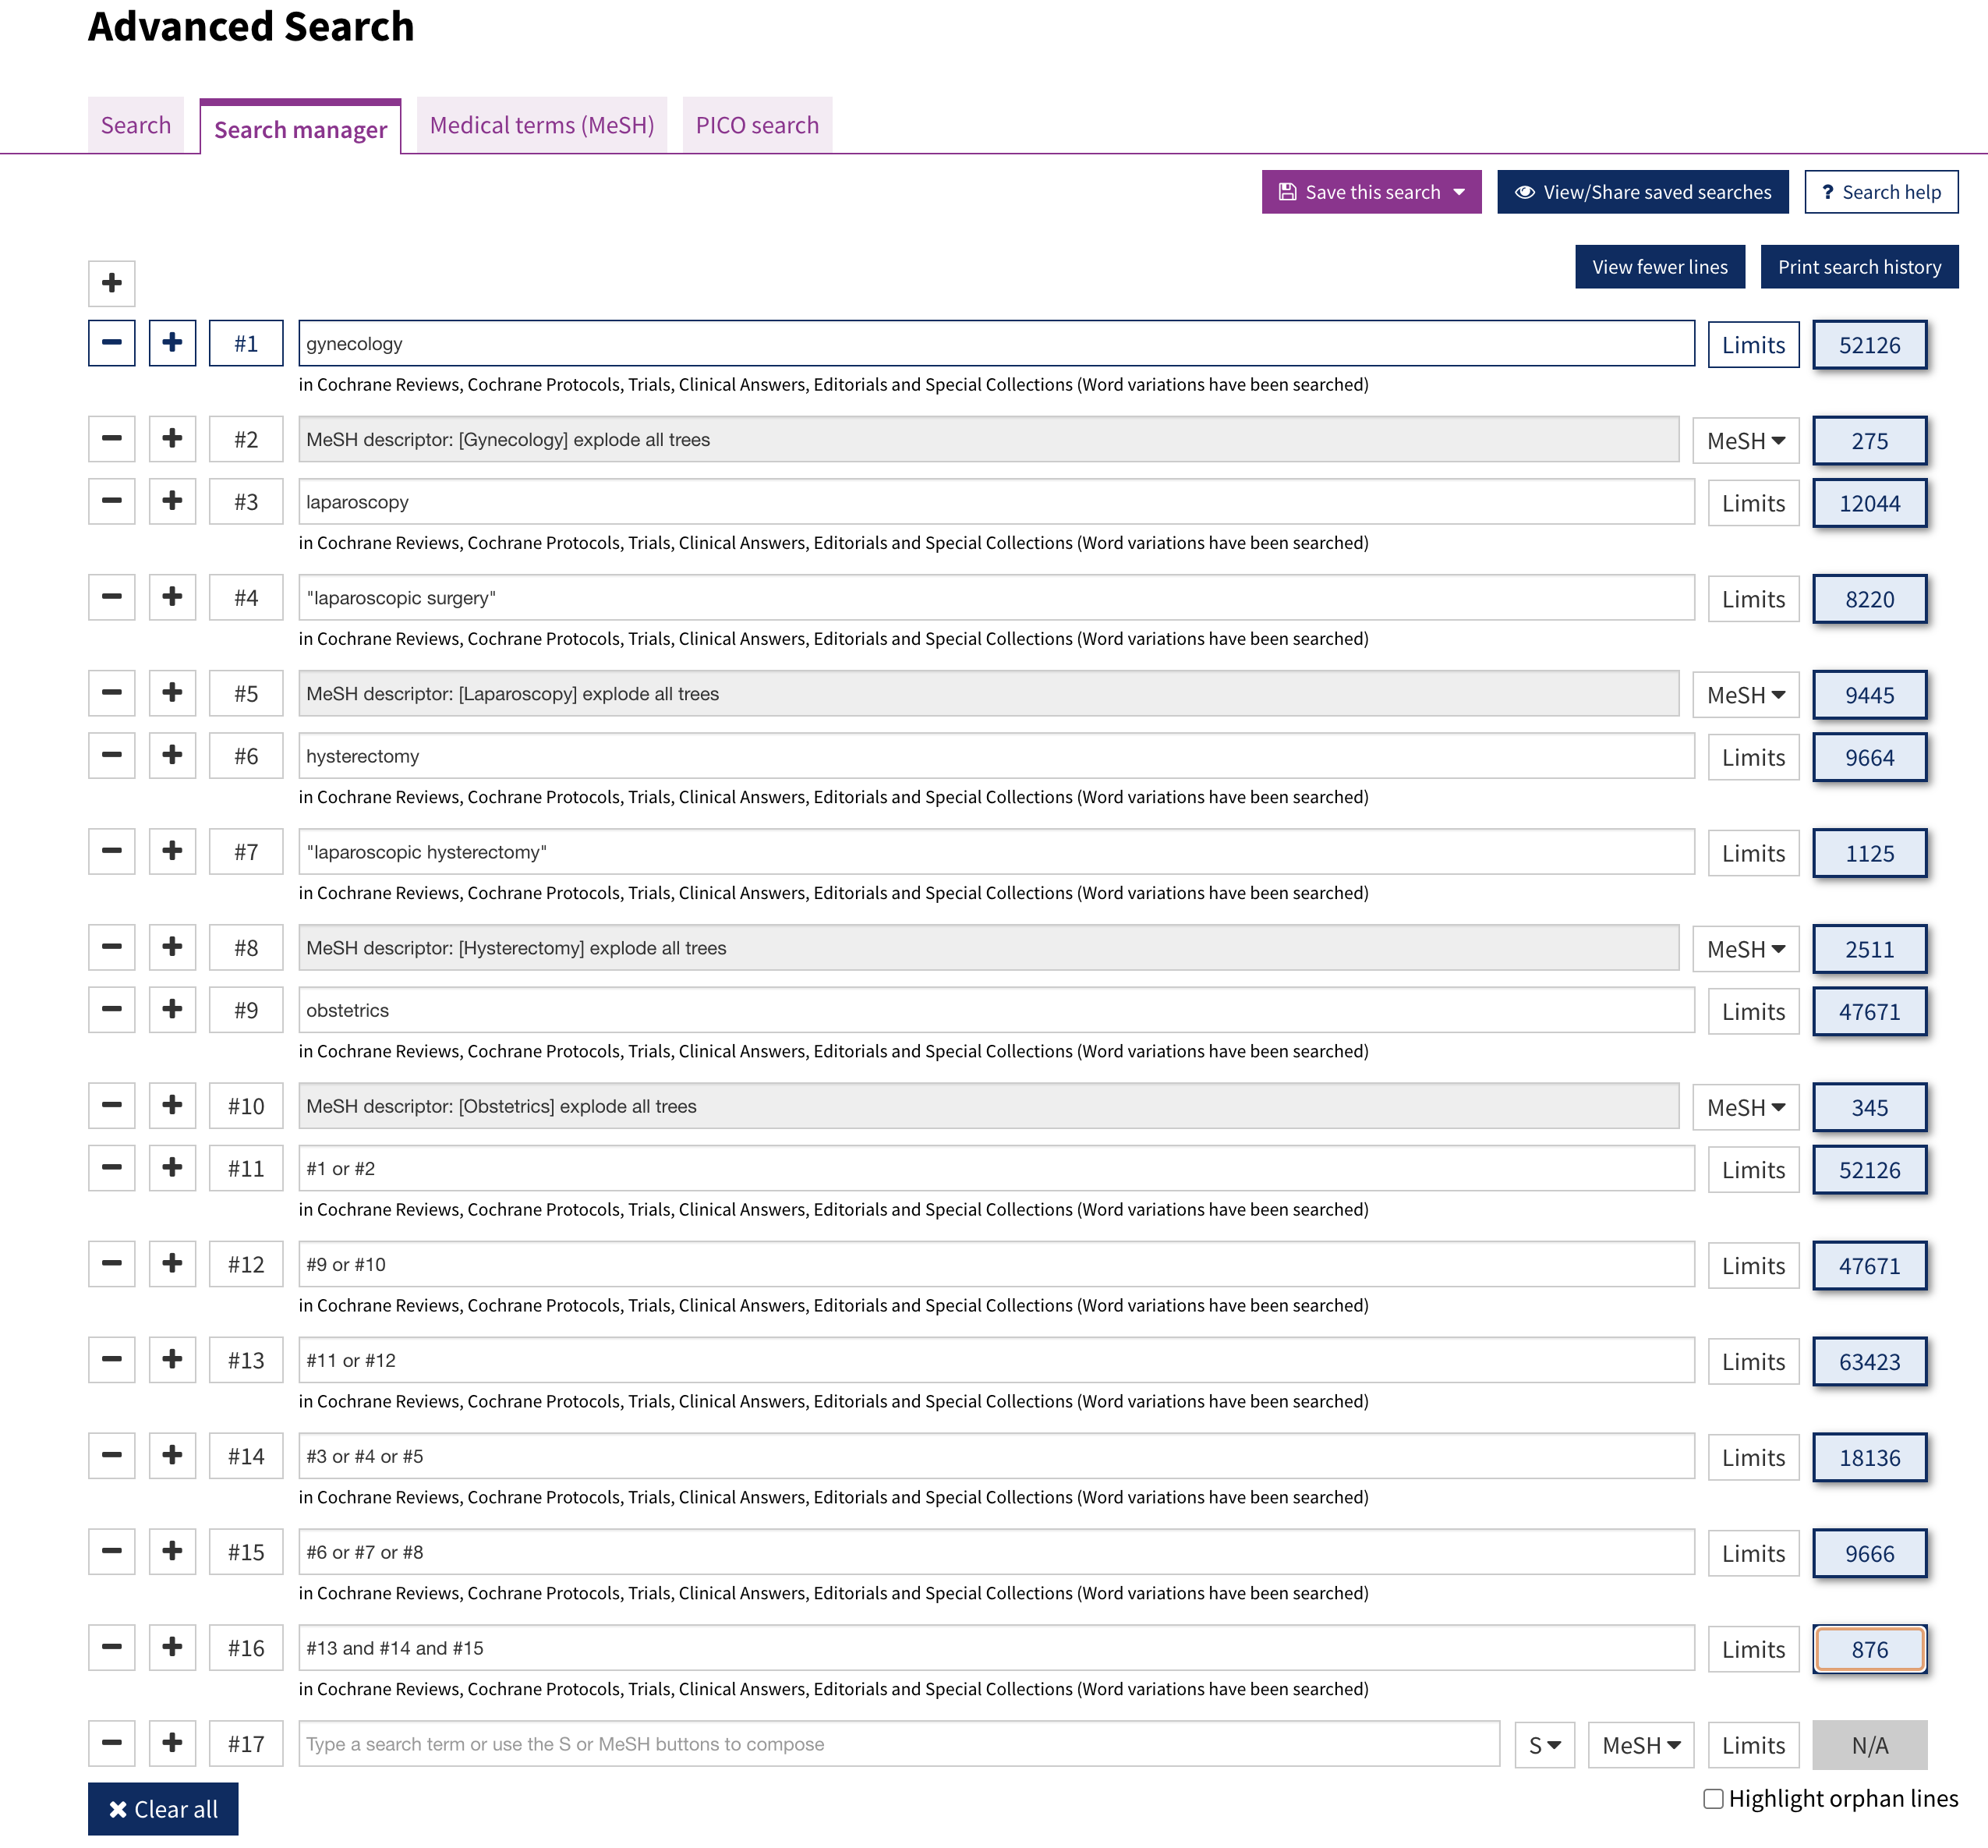
Results 876

- SUPPLEMENTARY TABLES

Table S1. Detailed inclusion and exclusion criteria.
Inclusion Criteria | Exclusion Criteria
studies enrolling women with endometrial and cervical malignancies of any stage requiring hysterectomy | studies enrolling women requiring hysterectomy for benign diseases or studies enrolling mixed populations (with malignant and benign disease) without stratifying or subgrouping (benign and malignant subgroup) their results
type of hysterectomy: total hysterectomy with or without bilateral salpingo-oophorectomy with or without pelvic lymphadenectomy with or without para-aortic lymphadenectomy | type of hysterectomy: supracervical hysterectomy
surgical approach (intervention group): minimally invasive surgery, namely laparoscopic hysterectomy, laparoscopically assisted vaginal hysterectomy, robot-assisted laparoscopic hysterectomy/robotic hysterectomy | studies where both population arms include patients who underwent other minimally invasive techniques than those described in the inclusion criteria (ex. vNOTEs)
surgical approach (comparator group): abdominal hysterectomy or any type of minimally invasive surgery (different than the one used in the intervention group) | studies where both population arms include patients who underwent other types of surgical hysterectomy approaches (ex., total vaginal versus total abdominal)
 | studies where the comparator were drugs, regiments, surgical devices, or suturing techniques among patients who underwent the same surgical approach
studies that assess at least one of the following outcomes: operative time, intraoperative blood loss, hemoglobulin reduction, hospitalization duration, total number of patients with at least one complication, total number of complications (events), intraoperative and postoperative complications (events), blood transfusion rates, cancer recurrence rates at the end of follow-up, death rates (total and cancer-related) at the end of follow-up and overall, disease-free and disease-specific survival | studies which do not assess at least one of the outcomes of interest
 | studies that only assess pain scores and pain management, pelvic floor function, sexual function, and quality-of-life

Table S2. The predefined list of variables and outcomes.
Domain | Details
Basic Study Information | Title, NTC number, Citation, Year of publication, Country of origin, Report IDs or other reports of the study, Type of Study, Author IDs, Contact details, Funding sources, Possible conflicts of interest.
Methods | Design of the study, Randomization process, Follow-ups
Participants | Inclusion and exclusion criteria, Sample size, Baseline characteristics with their summary measures, Baseline imbalances, Co-morbidities, Subgroups reported, Exclusions and withdrawals after allocation
Intervention - Control | TLH or LAVH or RALH/TRH versus TAH or TLH or LAVH or RALH/TRH, Conduction of BSO, Conduction of pelvic lymphadenectomy, Conduction of para-aortic lymphadenectomy
Outcomes | Definitions of the outcomes will be reported. All numeric outcomes will be recorded as mean/median, SD/IQR. All categoric outcomes will be recorded as the total number of events with their relevant Odds Ratio (OR) or Risk Ratio (RR) with their 95% Confidence Interval (CI). Overall survival, Disease-free survival, and Disease-specific survival will be recorded as percentages with their relevant 95% CI, and the rate ratios will be computed. Hazard Ratios (HR) and their 95% CI will be recorded.
Results | Per outcome: Time points, Total number of participants, Number of participants per group, number of events per group, number of lost to follow-up participants and reasons per group, Number of missing data per group, Baseline data with their summary measures, An estimate of effect with p-values and 95% Confidence Interval (CI).  Other results reported, Statistical methods used, Reanalysis (if required), Potential subgroups, and subgroup analysis (age, BMI, cancer stage, cancer type, type of MIS).
Applicability | Have important populations been excluded from the study? Is the intervention likely to be aimed at disadvantaged groups? Does the study directly address the review question?
Other Information | Key conclusions, References to other studies, Correspondence required for further study information, Further study information requested (3 times maximum), Correspondence received.
TLH: total laparoscopic Hysterectomy; LAVH: Laparoscopically Assisted Vaginal Hysterectomy; RALH/TRH: Robot-Assisted Laparoscopic Hysterectomy/Total Robotic Hysterectomy; TAH: Total Abdominal Hysterectomy; BSO: Bilateral Salpingo-Oophorectomy; SD: Standard Deviation; IQR: Interquartile Range; BMI: Body Mass Index; MIS: Minimally Invasive Surgery

Table S3. Ongoing studies found during the search of the grey literature.
Trial Code | Main Comparisons | Status
ChiCTR2000036517 | vNOTES¹ vs TU-LESS² | Phase 0
ChiCTR2000037611 | TLH³ vs TU-LSSS⁴ | Phase 0
ChiCTR2000037438 | TLH vs TU-LESS | Phase 0
NCT05974995 | TLH vs Robot-Assisted LH⁵ | Estimated Study Completion 2029
NCT02631837 | TLH vs vNOTES | Completed – Baekelandt 2019 (already found)
¹vNOTES: vaginal Natural Orifice Transluminal Endoscopic Surgery; ²TU-LESS: Transumbilical Laparo-Endoscopic Single-Site surgery; ³TLH: Total Laparoscopic Hysterectomy; ⁴TU-LSSS: Transumbilical Laparoscopic Single-Site surgery; ⁵LH: Laparoscopic Hysterectomy

Table S4. Reasons for exclusion of the potentially included studies
Reason(s) | Studies
Preliminary data of already included studies | Malur et al. 2001¹
Publication part of a trial whose results are presented in other included studies – no new outcome of interest assessed | Kondalsamy-Chennakesavan et al. 2012², Fader et al. 2016³
Publication part of a trial whose results are presented in other included studies and parallely:  - the comparators/interventions are not eligible based on the inclusion criteria of the review  - the publication contains stratification analysis, which does not constitute an outcome of interest for this review | Bishop et al. 2017⁴, Gunderson et al. 2014⁵
Population with malignant and benign disease (combined) without subgrouping the results | Kluivers et al. 2007⁶, Fanfani et al. 2013⁷, Long et al. 2002⁸, Ottosen et al. 2000⁹, Tsai et al. 2003¹⁰
Population without malignant disease | Deimling et al. 2016¹¹
No complications rates | Kornblith et al. 2009¹²
The study only assesses pain scores or/and quality of life scores or/and cost-effectiveness | Kornblith et al. 2009¹², Frumovitz et al. 2020¹³, Higgs et al.¹⁴

Table S5. Characteristics of the included studies.
ENDOMETRIAL CANCER
A. | Total Laparoscopic Hysterectomy (TLH) VS Total Abdominal Hysterectomy (TAH)
Study | Setting, design, and randomization | Population -Inclusion Criteria | Population - Exclusion Criteria | Study Arms | Study Arms at follow-ups | Intervention | Comparator(s) | Outcomes
Zullo et al. 2005⁷¹ | - Italy  - Single-center  - Randomization: computer-generated block numbers  - Intention-to-Treat  - Follow-up: 6 months | - Stage I | - Premenstrual syndrome  - Other (pre)cancer types  - Mental disease or drug use altering cognition, mood and vigilance  - Acute/Chronic disorders | - Total: 118  - TLH: 40  - TAH: 38  - Controls: 40 (only for quality-of-life assessment) | - Total: 118  - TLH: 40  - TAH: 38  - Controls: 40 (only for quality-of-life assessment) | - TLH with bilateral salpingo-oophorectomy and pelvic lymphadenectomy | - TAH with bilateral salpingo-oophorectomy and pelvic lymphadenectomy  - Control group only for quality-of-life assessment | - Operative time  - Intraoperative blood loss / hemoglobulin reduction  - Intraoperative complications  - Postoperative complications  - Hospitalization (duration)  - Pain assessment  - SF-36 quality of life assessment  - Kuppermann Index (climacteric symptoms assessment)
Zullo et al. 2009⁷² | - Italy  - Single-center  - Randomization: computer-generated block numbers  - Intention-to-Treat  - Follow-up: 7 years | - Stage I | - Premenstrual syndrome  - Other (pre)cancer types  - Mental disease or drug use altering cognition, mood and vigilance  - Acute/Chronic disorders | - Total: 118  - TLH: 40  - TAH: 38  - Controls: 40 (only for quality-of-life assessment) | - Total: 118  - TLH: 40  - TAH: 38  - Controls: 40 (only for quality-of-life assessment) | - TLH with bilateral salpingo-oophorectomy and pelvic lymphadenectomy | - TAH with bilateral salpingo-oophorectomy and pelvic lymphadenectomy  - Control group only for quality-of-life assessment | - Overall survival / death rate  - Disease-free survival / recurrence rate  - Recurrence sites – metastases  - SF-36 quality of life assessment
Malzoni et al. 2009⁷³ | - Italy  - Single-center  - Randomization: computer-generated list  - Intention-to-Treat  - Follow-up: 3 years | - Stage I | - Metastases  - Lesions identified in ovaries  - Pathological “Papanicolaou” smear  - Uterus ≥12 gestational weeks  - Morcellation’s probability  - Systemic infections  - Renal, liver, cardiopulmonary and bone marrow disorders  - Inadequately regulated pulmonary obstructive disease  - Trendelenburg position not indicated  - Dorso-lithotomy position contraindicated due to hip disease  - Body Mass Index ≥ 40  - Age ≥ 80 years | - Total: 159  - TLH: 81  - TAH: 78 | - Total: 159  - TLH: 81  - TAH: 78 | - TLH with bilateral salpingo-oophorectomy and pelvic lymphadenectomy with/without para-aortic lymphadenectomy | - TAH with bilateral salpingo-oophorectomy and pelvic lymphadenectomy with/without para-aortic lymphadenectomy | - Operative time  - Intraoperative blood loss / hemoglobulin reduction  - Intraoperative complications  - Postoperative complications  - Hospitalization (duration)  - Overall survival / death rate  - Disease-free survival / recurrence rate  - Recurrence sites – metastases
Janda et al. 2010¹⁶ | - Australia, New Zealand, Hong Kong  - Part of the LACE trial  - Multi-center  - Randomization: computer-generated blocks  - Intention-to-Treat  - Follow-up: 6 months | - > 18 years  - Stage I endometrioid adenocarcinoma (of any grade) | - Other types (based on histology)  - Stages II–IV  - Uterus > 10 gestational weeks  - Life expectancy < 6 months  - Distance, follow-up and compliance issues | - Total: 332  - TLH: 190  - TAH: 142 | - Total: 290  - TLH: 172  - TAH: 118 | - TLH with bilateral salpingo-oophorectomy and pelvic lymphadenectomy with/without para-aortic lymphadenectomy | - TAH with bilateral salpingo-oophorectomy and pelvic lymphadenectomy with/without para-aortic lymphadenectomy | - Operative time  - Intraoperative blood loss / hemoglobulin reduction  - Intraoperative complications  - Postoperative complications  - Hospitalization (duration)  - Pain assessment  - Quality of life
Mourits et al. 2010⁷⁴ | - Netherlands  - Multi-center  - Randomization: computer-generated block numbers  - Intention-to-Treat  - Follow-up: 6 months | - Grade 1/2 endometrioid adenocarcinoma  - ≥ 8 years | - Other histology  - Stage II to IV  - Uterus > 10 gestational weeks  - Heart and lung contraindications for surgery | - Total: 279  - TLH: 185  - TAH: 94 | - Total: 279  - TLH: 185  - TAH: 94 | - TLH with bilateral salpingo-oophorectomy | - TAH with bilateral salpingo-oophorectomy | - Operative time  - Intraoperative blood loss / hemoglobulin reduction  - Intraoperative complications  - Postoperative complications  - Hospitalization (duration)  - Death rate  - Pain assessment  - Quality of life  - Quality of sexual life  - General health perception
Bijen et al. 2011⁷⁵ | - Netherlands  - Multi-center  - Randomization: computer-generated block numbers  - Intention-to-Treat  - Follow-up: 6 months | - Grade 1/2 endometrioid adenocarcinoma  - ≥ 8 years | - Other histology  - Stage II to IV  - Uterus > 10 gestational weeks  - Heart and lung contraindications for surgery | - Total: 279  - TLH: 185  - TAH: 94 | - Total: 279  - TLH: 185  - TAH: 94 | - TLH with bilateral salpingo-oophorectomy | - TAH with bilateral salpingo-oophorectomy | - Intraoperative complications  - Postoperative complications  - Cost-effectiveness
Kluivers et al. 2011⁷⁶ | - Netherlands  - Single-center  - Randomization: numbered sealed opaque envelopes  - Intention-to-Treat  - Follow-up: 5 years | - Atypical hyperplasia or/and carcinoma | - Above stage 1  - History of midline abdominal incision  - Uterus > 18 gestational weeks  - Need for parallel surgical operations  - Language barrier | - Total: 17  - TLH: 11  - TAH: 6 | - Total: 14  - TLH: 9  - TAH: 5 | - TLH with bilateral salpingo-oophorectomy | - TAH with bilateral salpingo-oophorectomy | - Operative time  - Intraoperative blood loss / hemoglobulin reduction  - Intraoperative complications  - Postoperative complications  - Hospitalization (duration)  - Death rate  - Recurrence rate  - Quality of life
Obermair et al. 2012⁷⁷ | - Australia, New Zealand, Hong Kong, Scotland  - Part of the LACE trial  - Multi-center  - Randomization: computer-generated blocks  - Intention-to-Treat  - Follow-up: 6 weeks | - > 18 years  - Stage I endometrioid adenocarcinoma (of any grade) | - Other types (based on histology)  - Stages II–IV  - Uterus > 10 gestational weeks  - Life expectancy < 6 months  - Distance, follow-up and compliance issues | - Total: 753  - TLH: 404  - TAH: 349 | - Total: 753  - TLH: 404  - TAH: 349 | - TLH with bilateral salpingo-oophorectomy and pelvic lymphadenectomy with/without para-aortic lymphadenectomy | - TAH with bilateral salpingo-oophorectomy and pelvic lymphadenectomy with/without para-aortic lymphadenectomy | - Operative time  - Intraoperative blood loss / hemoglobulin reduction  - Intraoperative complications  - Postoperative complications  - Hospitalization (duration)
Janda et al. 2017⁵ | - Australia, New Zealand, Hong Kong, Scotland  - Part of the LACE trial  - Multi-center  - Randomization: computer-generated blocks  - Intention-to-Treat  - Follow-up: 4.5 years | - > 18 years  - Stage I endometrioid adenocarcinoma (of any grade) | - Other types (based on histology)  - Stages II–IV  - Uterus > 10 gestational weeks  - Life expectancy < 6 months  - Distance, follow-up and compliance issues | - Total: 760  - TLH: 407  - TAH: 353 | - Total: 679  - TLH: 365  - TAH: 314 | - TLH with bilateral salpingo-oophorectomy and pelvic lymphadenectomy with/without para-aortic lymphadenectomy | - TAH with bilateral salpingo-oophorectomy and pelvic lymphadenectomy with/without para-aortic lymphadenectomy | - Operative time  - Intraoperative blood loss / hemoglobulin reduction  - Overall survival / death rate  - Disease-free survival / recurrence rate  - Recurrence sites – metastases
Reijntjes et al. 2022⁷⁸ | - Netherlands  - Multi-center  - Randomization: computer-generated block numbers  - Intention-to-Treat  - Follow-up: 5 years | - Grade 1/2 endometrioid adenocarcinoma  - ≥ 8 years | - Other histology  - Stage II to IV  - Uterus > 10 gestational weeks  - Heart and lung contraindications for surgery | - Total: 279  - TLH: 185  - TAH: 94 | - Total: 263  - TLH: 175  - TAH: 88 | - TLH with bilateral salpingo-oophorectomy | - TAH with bilateral salpingo-oophorectomy | - Overall survival / death rate  - Disease-free survival / recurrence rate  - Disease-specific survival  - Recurrence sites – metastases
B. | Laparoscopically Assisted Vaginal Hysterectomy (LAVH) VS Total Abdominal Hysterectomy (TAH)
Study | Setting, design, and randomization | Population -Inclusion Criteria | Population - Exclusion Criteria | Study Arms | Study Arms at follow-ups | Intervention | Comparator(s) | Outcomes
Fram et al. 2002⁷⁹ | - Australia  - Single-center  - Intention-to-Treat  - Follow-up: none | - Stage I | - Stage II and above | - Total: 61  - LAVH: 29  - TAH: 32 | - Not applicable | - LAVH with bilateral salpingo-oophorectomy with/without pelvic lymphadenectomy | - LAVH with bilateral salpingo-oophorectomy with/without pelvic lymphadenectomy | - Operative time  - Intraoperative blood loss / hemoglobulin reduction  - Intraoperative complications  - Postoperative complications  - Hospitalization (duration)
Tozzi et al. 2005a⁸⁰ | - Germany  - Single-center  - Randomization: by means of a centrally managed random number table  - Intention-to-Treat  - Follow-up: 6 months | - Cancer confirmed by histology | - Ultrasound revealing transverse uterus diameter > 8 cm | - Total: 122  - LAVH: 63  - TAH: 59 | - Total: 122  - LAVH: 63  - TAH: 59 | - LAVH with bilateral salpingo-oophorectomy with/without pelvic lymphadenectomy with/without para-aortic lymphadenectomy | - TAH with bilateral salpingo-oophorectomy with/without pelvic lymphadenectomy with/without para-aortic lymphadenectomy | - Intraoperative complications  - Postoperative complications
Tozzi et al. 2005b⁸¹ | - Germany  - Single-center  - Randomization: centrally managed random number table means  - Intention-to-Treat  - Follow-up: 5 years | - Cancer confirmed by histology | - Ultrasound revealing transverse uterus diameter > 8 cm | - Total: 122  - LAVH: 63  - TAH: 59 | - Total: 108 at 2-year follow-up and 75 at 5-year follow-up | - LAVH with bilateral salpingo-oophorectomy with/without pelvic lymphadenectomy with/without para-aortic lymphadenectomy | - TAH with bilateral salpingo-oophorectomy with/without pelvic lymphadenectomy with/without para-aortic lymphadenectomy | - Intraoperative blood loss / hemoglobulin reduction  - Hospitalization (duration)  - Overall survival / death rate  - Disease-free survival / recurrence rate  - Disease-specific survival  - Recurrence sites – metastases
C. | Robot-Assisted Laparoscopic Hysterectomy (RALH) VS Total Abdominal Hysterectomy (TAH)
Study | Setting, design and randomization | Population -Inclusion Criteria | Population - Exclusion Criteria | Study's Arms | Study's Arms at follow-ups | Intervention | Comparator(s) | Outcomes
Salehi et al. 2017⁸² | - Sweden  - Single-center  - Randomization: blocked by sealed envelopes  - Per-protocol  - Follow-up: 30 days | - Age 18 – 75 years  - Stage I/II  - Grade 3 endometrioid carcinoma  - Grade 2 endometrioid carcinoma with ≥ 50% tumor invasion in the myometrium or the cervical stroma  - Non-endometrioid carcinoma | - Advanced cancer (extrauterine metastasis) based on imaging  - Ongoing anticancer therapy  - Compliance issues | - Total: 96  - RALH: 48  - TAH: 48 | - Total: 96  - RALH: 48  - TAH: 48 | - RALH with bilateral salpingo-oophorectomy and pelvic lymphadenectomy with/without para-aortic lymphadenectomy | - TAH with bilateral salpingo-oophorectomy and pelvic lymphadenectomy with/without para-aortic lymphadenectomy | - Operative time  - Intraoperative blood loss / hemoglobulin reduction  - Intraoperative complications  - Postoperative complications  - Hospitalization (duration)  - Cost-effectiveness
D. | Minimally Invasive Hysterectomy (MIH – TLH or LAVH or TRH) VS Total Abdominal Hysterectomy (TAH)
Study | Setting, design, and randomization | Population -Inclusion Criteria | Population - Exclusion Criteria | Study Arms | Study Arms at follow-ups | Intervention | Comparator(s) | Outcomes
Walker et al. 2009⁸³ | - United States  - Multi-center  - Randomization: permuted block design  - Intention-to-Treat  - Follow-up: 6 weeks | - Stage I/IIA  - Sufficient renal, liver and bone marrow function  - No evidence of tumor among patients with medical history of cancer | - Not specified on the paper (apparently patients who did not meet the inclusion criteria) | - Total: 2591  - MIH: 1682  - TAH: 909 | - Total: 2591  - MIH: 1682  - TAH: 909 | - MIH (TLH or LAVH or TRH) with bilateral salpingo-oophorectomy and pelvic lymphadenectomy with para-aortic lymphadenectomy | - TAH with bilateral salpingo-oophorectomy and pelvic lymphadenectomy with para-aortic lymphadenectomy | - Operative time  - Intraoperative complications  - Postoperative complications  - Hospitalization
Walker et al. 2012⁸⁴ | - United States  - Multi-center  - Randomization: permuted block design  - Intention-to-Treat  - Follow-up: 5 years | - Stage I/IIA  - Sufficient renal, liver and bone marrow function  - No evidence of tumor among patients with medical history of cancer | - Not specified on the paper (apparently patients who did not meet the inclusion criteria) | - Total: 2889  - MIH: 1969  - TAH: 920 | - Total: 2889  - MIH: 1969  - TAH: 920 | - MIH (TLH or LAVH or TRH) with bilateral salpingo-oophorectomy and pelvic lymphadenectomy with para-aortic lymphadenectomy | - TAH with bilateral salpingo-oophorectomy and pelvic lymphadenectomy with para-aortic lymphadenectomy | - Overall survival / death rate  - Recurrence rate  - Recurrence sites – metastases
E. | Laparoscopically Assisted Vaginal Hysterectomy (LAVH) VS Total Laparoscopic Hysterectomy (TLH)
Study | Setting, design, and randomization | Population -Inclusion Criteria | Population - Exclusion Criteria | Study Arms | Study Arms at follow-ups | Intervention | Comparator(s) | Outcomes
Ghezzi et al. 2006⁸⁵ | - Italy  - Two-center  - Randomization: computer-generated list  - Intention-to-Treat  - Follow-up: 2 years | - Endometrial cancer | - Age > 75 years  - Uterus ≥ gestational 12 weeks  - Cardiopulmonary disease  - Metastasis | - Total: 72  - LAVH: 37  - TAH: 35 | - Total: 72  - LAVH: 37  - TAH: 35 | - LAVH with bilateral salpingo-oophorectomy and pelvic lymphadenectomy | - TLH with bilateral salpingo-oophorectomy and pelvic lymphadenectomy | - Operative time  - Intraoperative blood loss / hemoglobulin reduction  - Intraoperative complications  - Postoperative complications  - Hospitalization (duration)  - Recurrence rate  - Recurrence sites – metastases
F. | Total Laparoscopic Hysterectomy (TLH) VS Robot-Assisted Laparoscopic Hysterectomy (RALH)
Study | Setting, desig,n and randomization | Population -Inclusion Criteria | Population - Exclusion Criteria | Study Arms | Study Arms at follow-ups | Intervention | Comparator(s) | Outcomes
Mäenpää et al. 2016⁸⁶ | - Finland  - Single-center  - Randomization: minimization software  - Intention-to-Treat  - Follow-up: 6 months | - Grade 1/2 carcinoma | - Narrow vagina  - Large uterus which cannot be removed through vagina  - Trendelenburg position contraindications | - Total: 101  - TLH: 51  - RALH: 50 | - Total: 99  - TLH: 49  - RALH: 50 | - TLH with bilateral salpingo-oophorectomy and pelvic lymphadenectomy | - RALH with bilateral salpingo-oophorectomy and pelvic lymphadenectomy | - Operative time  - Intraoperative blood loss / hemoglobulin reduction  - Intraoperative complications  - Postoperative complications  - Hospitalization (duration)
CERVICAL CANCER
A. | Total Laparoscopic Hysterectomy (TLH) VS Total Abdominal Hysterectomy (TAH)
Study | Setting, design, and randomization | Population -Inclusion Criteria | Population - Exclusion Criteria | Study Arms | Study Arms at follow-ups | Intervention | Comparator(s) | Outcomes
Campos et al. 2013⁸⁷ | - Brazil  - Single-center  - Randomization: random number table generated by an independent author  - Intention-to-Treat  - Follow-up: 5 years | - ≥18 years  - Adenocarcinoma, squamous, or adenosquamous carcinomas (confirmed by histology)  - Stage IA2  - IB or IIA lymph vascular invasion | - Stages IIB-IV  - Gestation  - Medical history of abdominal or pelvic radiotherapy  - Renal, liver, cardiopulmonary and bone marrow disorders  - Inadequately regulated pulmonary obstructive disease  - Trendelenburg position not indicated  - Dorso-lithotomy position contraindicated due to hip disease | - Total: 30  - TLH: 16  - TAH: 14 | - Total: 30  - TLH: 16  - TAH: 14 | - TLH with bilateral salpingo-oophorectomy and pelvic lymphadenectomy | - TAH with bilateral salpingo-oophorectomy and pelvic lymphadenectomy | - Operative time  - Intraoperative complications  - Postoperative complications  - Pain assessment
Xu et al. 2020⁸⁸ | - China  - Two-center  - Randomization: random number table  - Intention-to-Treat  - Follow-up: none | - Stages IA/IB/IIA/IIB  - Adenocarcinoma, squamous, or adenosquamous carcinomas (confirmed by histology) | - Other cancer types  - Immune deficiency  - Immune enhancement therapy after surgery  - Autoimmune diseases | - Total: 168  - TLH: 84  - TAH: 84 | Not applicable | - TLH with bilateral salpingo-oophorectomy and pelvic lymphadenectomy | - TAH with bilateral salpingo-oophorectomy and pelvic lymphadenectomy | - Operative time  - Intraoperative blood loss / hemoglobulin reduction  - Intraoperative complications  - Postoperative complications  - Hospitalization (duration)  - Pain assessment
Campos et al. 2021⁸⁹ | - Brazil  - Single-center  - Randomization: random number table generated by an independent author  - Intention-to-Treat  - Follow-up: 5 years | - ≥18 years  - Adenocarcinoma, squamous, or adenosquamous carcinomas (confirmed by histology)  - Stage IA2  - IB or IIA lymph vascular invasion | - Stages IIB-IV  - Gestation  - Medical history of abdominal or pelvic radiotherapy  - Renal, liver, cardiopulmonary and bone marrow disorders  - Inadequately regulated pulmonary obstructive disease  - Trendelenburg position not indicated  - Dorso-lithotomy position contraindicated due to hip disease | - Total: 30  - TLH: 16  - TAH: 14 | - Total: 30  - TLH: 16  TAH: 14 | - TLH with bilateral salpingo-oophorectomy and pelvic lymphadenectomy | - TAH with bilateral salpingo-oophorectomy and pelvic lymphadenectomy | - Overall survival / death rate  - Disease-free survival / recurrence rate  - Recurrence sites – metastases
Xin LV et al. 2023⁹⁰ | - China  - Single-center  - Randomization: network-based computer program  - Per-Protocol  - Follow-up: 4.5 years | - Stages IA1/IA2/IB1  - Tumor < 2 cm  - Adenocarcinoma, squamous-cell carcinoma, and adenosquamous carcinoma, except  - Normal liver, renal and hematopoietic function  - Body Mass Index below 35  - Age: 18 – 70 | - Stages IB2 and above  - Tumor ≥ 2cm  - Outer 1/3 of the stroma’s invasion  - Lower uterine segment’s involvement  - Endometrioid adenocarcinoma  - Mental diseases  - Liver, renal and heart disease  - Bladder dysfunction  - Radio- or chemotherapy  - Gestation  - Body Mass Index equal to or greater than 35  - Follow-up, distance and compliance issues | - Total: 34  - TLH: 17  - TAH: 17 | - Total: 34  - TLH: 17  - TAH: 17 | - TLH with bilateral salpingo-oophorectomy and pelvic lymphadenectomy with/without para-aortic lymphadenectomy | - TAH with bilateral salpingo-oophorectomy and pelvic lymphadenectomy with/without para-aortic lymphadenectomy | - Operative time  - Intraoperative blood loss / hemoglobulin reduction  - Intraoperative complications  - Postoperative complications  - Hospitalization (duration)  - Recurrence rate
B. | Laparoscopically Assisted Vaginal Hysterectomy (LAVH) VS Total Abdominal Hysterectomy (TAH)
Study | Setting, design and randomization | Population -Inclusion Criteria | Population - Exclusion Criteria | Study Arms | Study Arms at follow-ups | Intervention | Comparator(s) | Outcomes
Naik et al. 2010⁹¹ | - United Kingdom  - Single-center  - Randomization by computer-generated blocks  - Intention-to-Treat  - No follow-up | - Stage IB1 (confirmed by histology)  - Tumor < 2 cm | - Gestation  - High-risk subtypes, (glassy cell, clear cell)  - Simultaneous malignancy or history of malignancy | - Total: 13  - LAVH: 7  - TAH: 6 | - Total: 13  - LAVH: 7  - TAH: 6 | - LAVH with bilateral salpingo-oophorectomy | - TAH with bilateral salpingo-oophorectomy | - Operative time  - Intraoperative blood loss / hemoglobulin reduction  - Intraoperative complications  - Postoperative complications  - Hospitalization (duration)  - Pain assessment
C. | Minimally Invasive Hysterectomy (MIH – TLH or LAVH or RALH/TRH) VS Total Abdominal Hysterectomy (TAH)
Study | Setting, design and randomization | Population -Inclusion Criteria | Population - Exclusion Criteria | Study Arms | Study Arms at follow-ups | Intervention | Comparator(s) | Outcomes
Ramirez et al. 2018⁸ | - United States, Argentina, Australia, Brazil, Bulgaria, Canada, China, Colombia, Italy, South Korea, Mexico, Peru, Puerto Rico  - Multi-center  - Part of the LACC trial  - Randomization: web-based by minimization software  - Intention-to-Treat  - Follow-up: 4.5 years | - ≥ 18 years  - Cervical adenocarcinoma, squamous cell, or adenosquamous carcinoma  - Stages IA1 (lymph/vascular invasion), IA2 (stromal invasion, 3 to 5 mm in depth and <7 mm in width), or IB1 (tumor size of ≤4 cm in the greatest dimension and no node involvement) | - Gestation  - Severe systemic disorders  - Uterus > 12 cm  - Administration of abdominal or pelvic radiotherapy in the past  - Stages IB2–IV - tumor > 4 cm  - Histology types of serous cell, neuroendocrine and clear cell carcinomas  - Life expectancy < 6 months  - Suspicion of metastasis by PET and CT scan (aortic lymph nodes > 2 cm positive for metastasis after CT–guided biopsy)  - Medical history of retroperitoneal operations  - Compliance issues or distance issues  - Issues regarding lithotomy and Trendelenburg position  - Triphenylmethane allergy | - Total: 631  - MIH: 319  - TAH: 312 | - Total: 526  - MIH: 271  - TAH: 255 | - MIH (TLH or TRH) with bilateral salpingo-oophorectomy and pelvic lymphadenectomy | - TAH with bilateral salpingo-oophorectomy and pelvic lymphadenectomy | - Hospitalization (duration)  - Overall survival / death rate  - Disease-free survival / recurrence rate  - Disease-specific survival  - Recurrence sites – metastases
Obermair et al. 2020⁹² | - United States, Argentina, Australia, Brazil, Bulgaria, Canada, China, Colombia, Italy, South Korea, Mexico, Peru, Puerto Rico  - Multi-center  - Part of the LACC trial  - Randomization: web-based by minimization software  - Intention-to-Treat  - Follow-up: 6 months | - ≥ 18 years  - Cervical adenocarcinoma, squamous cell, or adenosquamous carcinoma  - Stages IA1 (lymph/vascular invasion), IA2 (stromal invasion, 3 to 5 mm in depth and <7 mm in width), or IB1 (tumor size of ≤4 cm in the greatest dimension and no node involvement) | - Gestation  - Severe systemic disorders  - Uterus > 12 cm  - Administration of abdominal or pelvic radiotherapy in the past  - Stages IB2–IV - tumor > 4 cm  - Histology types of serous cell, neuroendocrine and clear cell carcinomas  - Life expectancy < 6 months  - Suspicion of metastasis by PET and CT scan (aortic lymph nodes > 2 cm positive for metastasis after CT–guided biopsy)  - Medical history of retroperitoneal operations  - Compliance issues or distance issues  - Issues regarding lithotomy and Trendelenburg position  - Triphenylmethane allergy | - Total: 536  - MIH: 279  - TAH: 257 | - Total: 536  - MIH: 279  - TAH: 257 | - MIH (TLH or TRH) with bilateral salpingo-oophorectomy and pelvic lymphadenectomy | - TAH with bilateral salpingo-oophorectomy and pelvic lymphadenectomy | - Operative time  - Intraoperative blood loss / hemoglobulin reduction  - Intraoperative complications  - Postoperative complications  - Hospitalization (duration)  - Pain assessment
Zhu et al. 2022⁹³ | - China  - Single-center  - Randomization: random number table  - Intention-to-Treat  - Follow up: 5 years | - Stages IB1-IIA2  - Adenocarcinoma or adenosquamous carcinoma confirmed by biopsy  - Normal liver, renal and hemostasis function | - Other histological types  - Advanced disease  - Follow-up issues | - Total: 188  - MIH: 94  - TAH: 94 | - Total: 188  - MIH: 94  - TAH: 94 | - MIH with bilateral salpingo-oophorectomy and pelvic lymphadenectomy with para-aortic lymphadenectomy | - TAH with bilateral salpingo-oophorectomy and pelvic lymphadenectomy with para-aortic lymphadenectomy | - Operative time  - Intraoperative blood loss / hemoglobulin reduction  - Intraoperative complications  - Postoperative complications  - Hospitalization (duration)  - Overall survival / death rate  - Disease-free survival / recurrence rate  - Recurrence sites – metastases
Ramirez et al. 2024¹⁹ | - United States, Argentina, Australia, Brazil, Bulgaria, Canada, China, Colombia, Italy, South Korea, Mexico, Peru, Puerto Rico  - Multi-center  - Part of the LACC trial  - Randomization: web-based by minimization software  - Intention-to-Treat  - Follow-up: 4.5 years | - ≥ 18 years  - Cervical adenocarcinoma, squamous cell, or adenosquamous carcinoma  - Stages IA1 (lymph/vascular invasion), IA2 (stromal invasion, 3 to 5 mm in depth and <7 mm in width), or IB1 (tumor size of ≤4 cm in the greatest dimension and no node involvement) | - Gestation  - Severe systemic diseases  - Uterus > 12 cm  - Administration of abdominal or pelvic radiotherapy in the past  - Stages IB2–IV - tumor > 4 cm  - Histology types of serous cell, neuroendocrine and clear cell carcinomas  - Life expectancy < 6 months  - Suspicion of metastasis by PET and CT scan (aortic lymph nodes > 2 cm positive for metastasis after CT–guided biopsy)  - Medical history of retroperitoneal operations  - Compliance issues or distance issues  - Issues regarding lithotomy and Trendelenburg position  - Triphenylmethane allergy | - Total: 631  - MIH: 319  - TAH: 312 | - Total: 526  - MIH: 271  - TAH: 255 | - MIH (TLH or TRH) with bilateral salpingo-oophorectomy and pelvic lymphadenectomy | - TAH with bilateral salpingo-oophorectomy and pelvic lymphadenectomy | - Overall survival / death rate  - Disease-free survival / recurrence rate
D. | Laparoscopically Assisted Vaginal Hysterectomy (LAVH) VS Total Robotic Hysterectomy (TRH)
Study | Setting, design, and randomization | Population -Inclusion Criteria | Population - Exclusion Criteria | Study Arms | Study Arms at follow-ups | Intervention | Comparator(s) | Outcomes
Luo et al. 2018⁹⁴ | - China  - Single-center  - Randomization: computer-generated numbers in block design  - Intention-to-Treat  - Follow-up: 24 months | - Stages IA – IIB | - Heart, lung, renal and liver diseases  - Abdominal adhesions | - Total: 60  - LAVH: 30  - TRH: 30 | - Total: 60  - LAVH: 30  - TRH: 30 | - LAVH with bilateral salpingo-oophorectomy and pelvic lymphadenectomy | - TRH with bilateral salpingo-oophorectomy and pelvic lymphadenectomy | - Intraoperative complications  - Postoperative complications  - Hospitalization (duration)  - Death rate  - Recurrence rate  - Recurrence sites – metastases
MIXED MALIGNANCIES
A. | Total Laparoscopic Hysterectomy (TLH) VS Robot-Assisted Laparoscopic Hysterectomy (RALH)
Study | Setting, design, and randomization | Population -Inclusion Criteria | Population - Exclusion Criteria | Study Arms | Study Arms at follow-ups | Intervention | Comparator(s) | Outcomes
Narducci et al. 2020⁹⁵ | - France  - Multi-center  - Randomization: centrally by computer-generated permuted blocks  - As-treated for the analysis of perioperative morbidity and survival outcomes, Intention-to-Treat and Per-Protocol for the sensitivity analyses  - Follow-up: 2 years | - ≥18 years  - Life expectancy ≥12 weeks  - Child-Pugh ≤A7  - Medical history of antitumor therapy completed ≥20 days before enrollment | - Gestation/Lactation  - Metastases  - Mental disease  - Compliance, distance and follow-up issues | As-treated  Total: 369  TLH: 193  RALH: 176  Intention-to-Treat  Total: 369  TLH: 188  RALH: 181  Per-Protocol  Total: 362  TLH: 187  RALH: 175 | - | - TLH with bilateral salpingo-oophorectomy with/ without pelvic lymphadenectomy with/without para-aortic lymphadenectomy | - RALH with bilateral salpingo-oophorectomy with/ without pelvic lymphadenectomy with/without para-aortic lymphadenectomy | - Operative time  - Intraoperative blood loss / hemoglobulin reduction  - Intraoperative complications  - Postoperative complications  - Overall survival / death rate  - Disease-free survival / recurrence rate  - Quality-of-life assessment
TLH: total laparoscopic hysterectomy; TAH: total abdominal hysterectomy; LAVH: laparoscopically assisted vaginal hysterectomy; RALH: robot-assisted laparoscopic hysterectomy; MIH: minimally invasive hysterectomy; TRH: total robotic hysterectomy; US: ultrasound; CT: computed tomography; MRI. magnetic resonance imaging; PET: positron emission tomography; SIL-2R: soluble interleukin-2 receptor; TNF: tumor necrosis factor

Table S6. Risk of bias assessment of the candidate studies using the RoB 2 Cochrane risk-of-bias tool. Risk-of-bias assessment was conducted per outcome for each study.
ENDOMETRIAL CANCER
Study | Outcome | Randomization process | Deviations from intended interventions | Missing outcome data | Measurement of the outcome | Selection of the reported result | Overall Bias
Fram et al. 2002¹⁵ | Blood loss | Some concerns | Some concerns | Low | Some concerns | High | High
Fram et al. 2002¹⁵ | All other outcomes | Some concerns | Some concerns | Low | Low | Some concerns | Some concerns
Zorlu et al. 2005¹⁶ | All outcomes | High | Some concerns | Low | Some concerns | High | High
Tozzi et al. 2005a¹⁷ | All outcomes | Some concerns | Low | Low | Low | Low | Some concerns
Tozzi et al. 2005b¹⁸ | Blood loss | Some concerns | Some concerns | Low | Some concerns | Some concerns | Some concerns
Tozzi et al. 2005b¹⁸ | Recurrence and survival | Some concerns | Low | Some concerns | Low | Some concerns | Some concerns
Zullo et al. 2005¹⁹ | Blood loss | Some concerns | Low | Low | Some concerns | Some concerns | Some concerns
Zullo et al. 2005¹⁹ | All other outcomes | Some concerns | Low | Low | Low | Low | Some concerns
Ghezzi et al. 2006²⁰ | Blood loss | Low | Some concerns | Low | Low | Some concerns | Some concerns
Ghezzi et al. 2006²⁰ | All other outcomes | Low | Low | Low | Low | Low | Low
Zullo et al. 2009²¹ | Recurrence and survival | Some concerns | Low | Low | Low | Low | Some concerns
Walker et al. 2009²² | Complications | Some concerns | Some concerns | Low | Low | Low | Some concerns
Malzoni et al. 2009²³ | Blood loss | Some concerns | Low | Low | Some concerns | Some concerns | Some concerns
Malzoni et al. 2009²³ | Recurrence and survival | Some concerns | Low | Some concerns | Low | Low | Some concerns
Malzoni et al. 2009²³ | All other outcomes | Some concerns | Low | Low | Low | Low | Some concerns
Janda et al. 2010²⁴ | Blood loss/Hemoglobulin reduction | Low | Some concerns | Low | Low | Low | Some concerns
Janda et al. 2010²⁴ | All other outcomes | Low | Some concerns | Low | Low | Some concerns | Some concerns
Mourits et al. 2010²⁵ | Blood loss | Some concerns | Some concerns | Low | Low | Low | Some concerns
Mourits et al. 2010²⁵ | Survival | Some concerns | Some concerns | Low | Low | Low | Some concerns
Mourits et al. 2010²⁵ | All other outcomes | Some concerns | Some concerns | Low | Low | Low | Some concerns
Bijen et al. 2011²⁶ | All outcomes | Some concerns | Some concerns | Low | Low | Low | Some concerns
Kluivers et al. 2011²⁷ | Blood loss | Some concerns | Low | Low | High | Some concerns | High
Kluivers et al. 2011²⁷ | All other outcomes | Some concerns | Low | Low | Some concerns | Low | Some concerns
Walker et al. 2012²⁸ | Recurrence and survival | Some concerns | Some concerns | Low | Low | Low | Some concerns
Obermair et al. 2012²⁹ | Blood loss | Low | Some concerns | Low | Low | Low | Some concerns
Obermair et al. 2012²⁹ | All other outcomes | Low | Some concerns | Low | Low | Some concerns | Some concerns
Mäenpää et al. 2016³⁰ | Blood loss | Some concerns | Low | Low | Some concerns | Some concerns | Some concerns
Mäenpää et al. 2016³⁰ | All other outcomes | Some concerns | Low | Low | Low | Some concerns | Some concerns
Salehi et al. 2017³¹ | Blood loss | Some concerns | Some concerns | Some concerns | Some concerns | Low | Some concerns
Salehi et al. 2017³¹ | All other outcomes | Some concerns | Some concerns | Some concerns | Low | Low | Some concerns
Janda et al. 2017³² | Recurrence and survival | Low | Some concerns | Some concerns | Low | Some concerns | Some concerns
Reijntjes et al. 2022³³ | Recurrence and survival | Some concerns | Some concerns | Some concerns | Low | Low | Some concerns
CERVICAL CANCER
Study | Outcome | Randomization process | Deviations from intended interventions | Missing outcome data | Measurement of the outcome | Selection of the reported result | Overall Bias
Naik et al. 2010³⁴ | Blood loss | Low | Some concerns | Low | Some concerns | Low | Some concerns
Naik et al. 2010³⁴ | All other outcomes | Low | Some concerns | Low | Low | Low | Some concerns
Campos et al. 2013³⁵ | All outcomes | Some concerns | Low | Low | Low | Some concerns | Some concerns
Luo et al. 2018³⁶ | Recurrence and survival | Low | Low | Low | Some concerns | Some concerns | Some concerns
Luo et al. 2018³⁶ | All other outcomes | Low | Low | Low | Some concerns | Some concerns | Some concerns
Ramirez et al. 2018³⁷ | Recurrence and survival | Low | Some concerns | Low | Low | Some concerns | Some concerns
Ramirez et al. 2018³⁷ | All other outcomes | Low | Some concerns | Low | Low | Some concerns | Some concerns
Xu et al. 2020³⁸ | Blood loss | Some concerns | Some concerns | Low | Some concerns | Some concerns | Some concerns
Xu et al. 2020³⁸ | All other outcomes | Some concerns | Some concerns | Low | Low | Some concerns | Some concerns
Obermair et al. 2020³⁹ | Blood loss | Low | Some concerns | Low | Some concerns | Low | Some concerns
Obermair et al. 2020³⁹ | All other outcomes | Low | Low | Low | Low | Low | Low
Campos et al. 2021⁴⁰ | Recurrence and survival | Some concerns | Low | Low | Low | Some concerns | Some concerns
Zhu et al. 2022⁴¹ | Blood loss | Some concerns | Some concerns | Low | Some concerns | Some concerns | Some concerns
Zhu et al. 2022⁴¹ | Recurrence and survival | Some concerns | Some concerns | Some concerns | Low | Some concerns | Some concerns
Zhu et al. 2022⁴¹ | All other outcomes | Some concerns | Some concerns | Low | Low | Some concerns | Some concerns
Xin LV et al. 2023⁴² | Blood loss | Some concerns | Some concerns | Low | Some concerns | Low | Some concerns
Xin LV et al. 2023⁴² | Recurrence and survival | Some concerns | Low | Low | Low | Low | Some concerns
Xin LV et al. 2023⁴² | All other outcomes | Some concerns | Low | Low | Low | Low | Some concerns
Ramirez et al. 2024⁴³ | Recurrence and survival | Low | Some concerns | Low | Low | Some concerns | Some concerns
Xu H et al. 2024⁴⁴ | All outcomes | High | Some concerns | Low | Some concerns | Some concerns | High
MIXED MALIGNANCIES
Study | Outcome | Randomization process | Deviations from intended interventions | Missing outcome data | Measurement of the outcome | Selection of the reported result | Overall Bias
Narducci et al. 2020⁴⁵ | Blood loss | Some concerns | Some concerns | Some concerns | Some concerns | Low | Some concerns
Narducci et al. 2020⁴⁵ | Recurrence and survival | Some concerns | Some concerns | Some concerns | Low | Some concerns | Some concerns
Narducci et al. 2020⁴⁵ | All other outcomes | Some concerns | Some concerns | Some concerns | Low | Some concerns | Some concerns

- SUPPLEMENTARY FIGURES
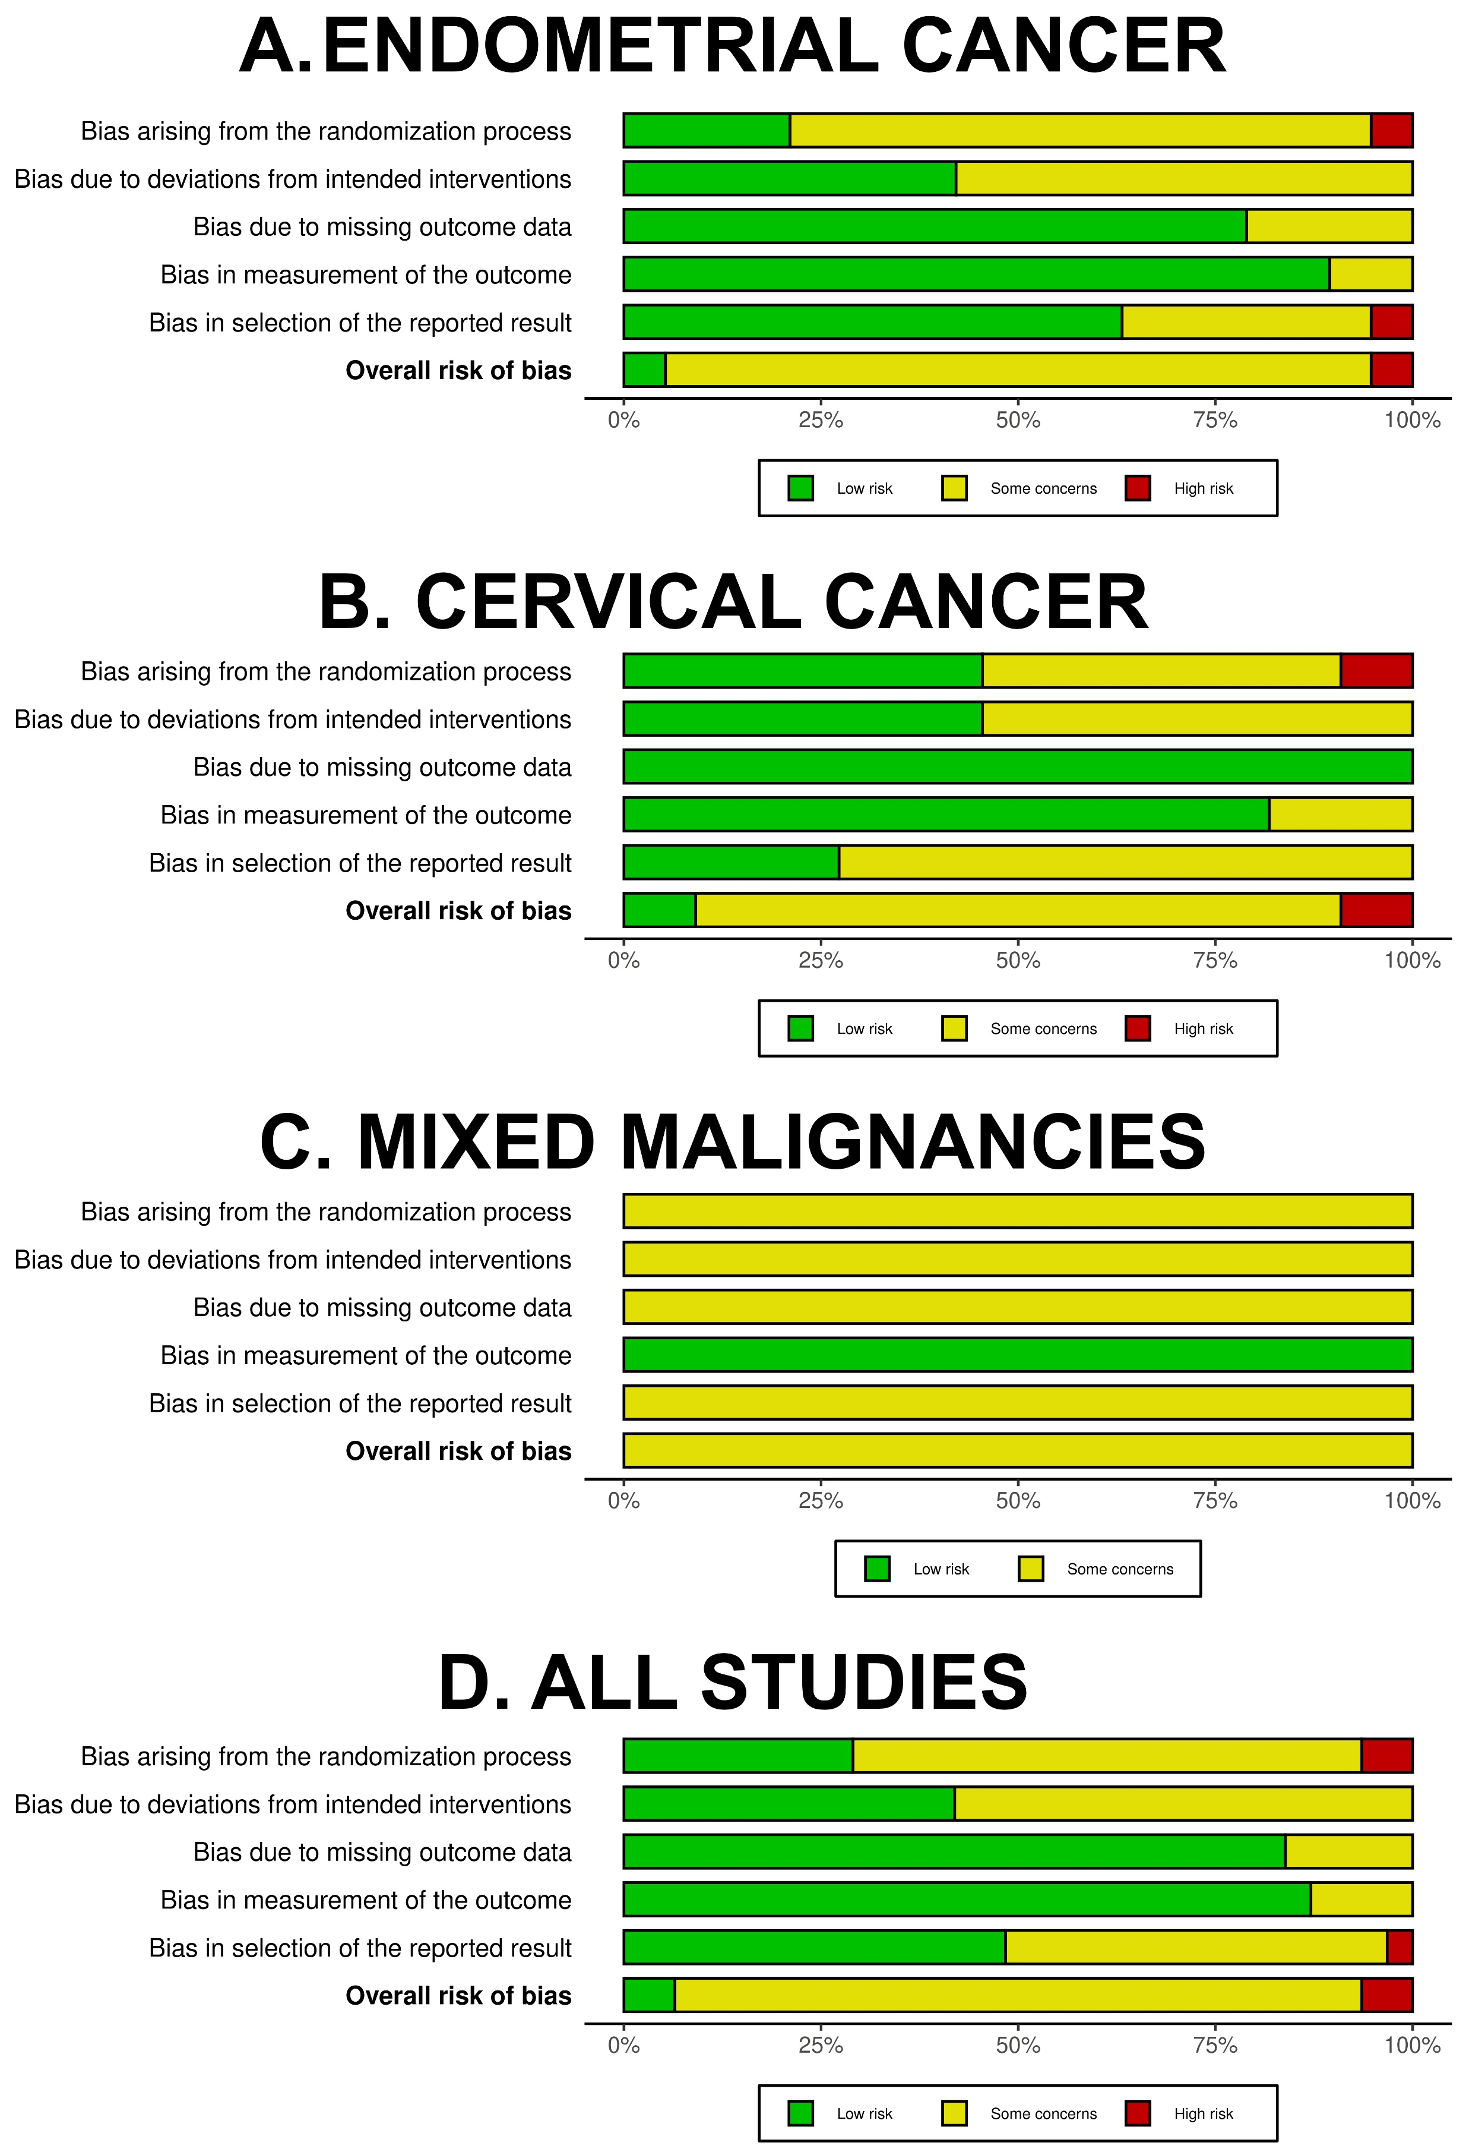
Figure S1. Summary plots for the Risk-of-Bias assessment (regarding all outcomes) with RoB 2 Cochrane tool. Studies are divided in three categories: (A) those enrolling patients with endometrial cancer, (B) those enrolling patients with cervical cancer, (C) those enrolling patients with endometrial or cervical or ovarian cancer, and (D) all studies together.
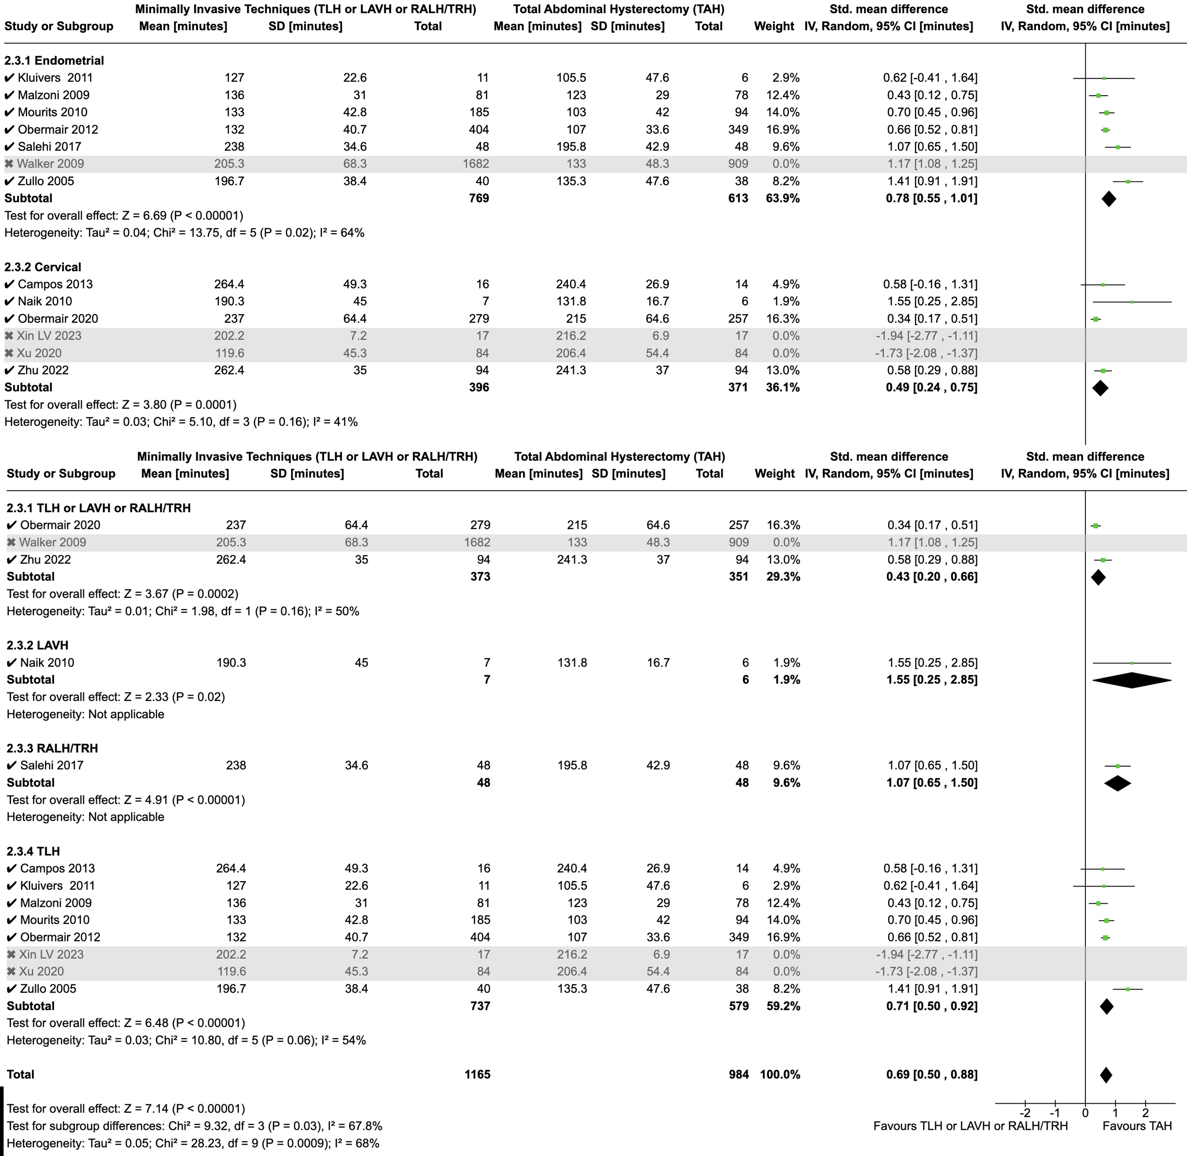
Figure S2. Forest plots regarding Operative Time per cancer-type and surgery subgroups and for the whole population. Studies highlighted in grey are those excluded during sensitivity analysis since creating non-acceptable statistical heterogeneity (I²≥75%).
Abbreviations: TLH: Total Laparoscopic Hysterectomy; LAVH: Laparoscopically Assisted Vaginal Hysterectomy; RALH/TRH: Robot Assisted Laparoscopic Hysterectomy/Total Robotic Hysterectomy; TAH: Total Abdominal Hysterectomy

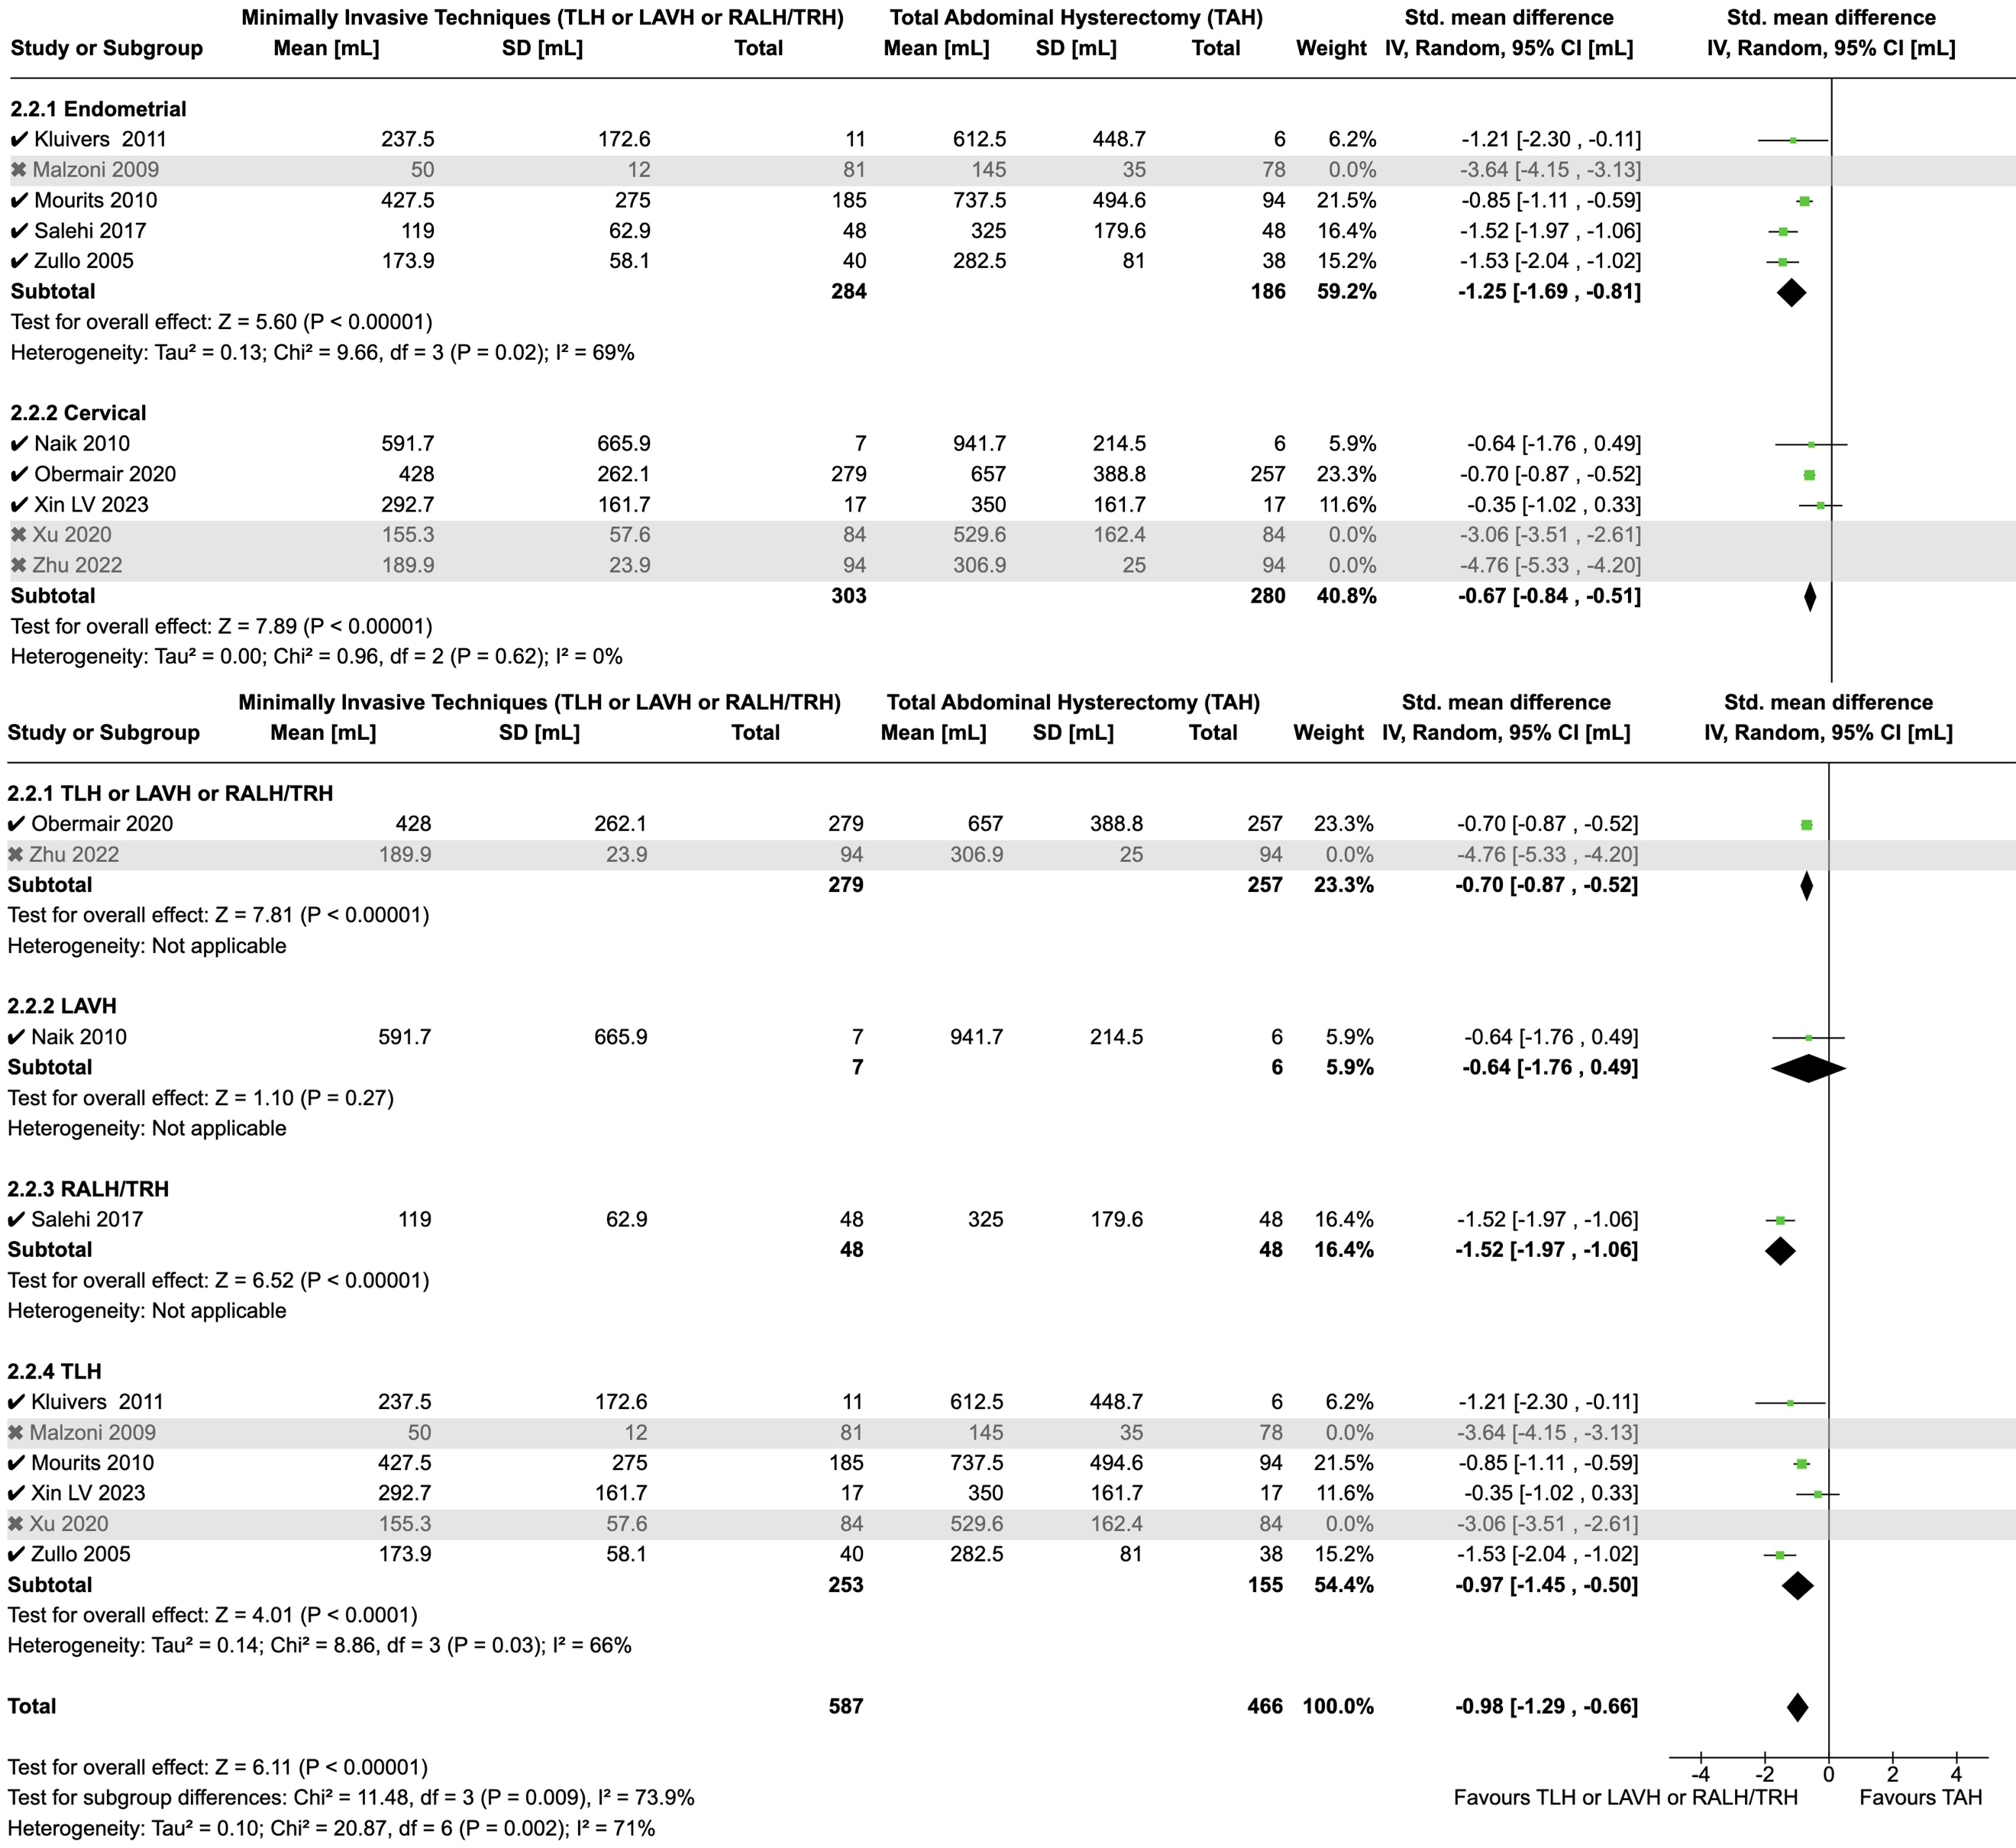
Figure S3. Forest plots regarding Intraoperative Blood Loss per cancer-type and surgery subgroups and for the whole population. Studies highlighted in grey are those excluded during sensitivity analysis since creating non-acceptable statistical heterogeneity (I²≥75%).
Abbreviations: TLH: Total Laparoscopic Hysterectomy; LAVH: Laparoscopically Assisted Vaginal Hysterectomy; RALH/TRH: Robot Assisted Laparoscopic Hysterectomy/Total Robotic Hysterectomy; TAH: Total Abdominal Hysterectomy

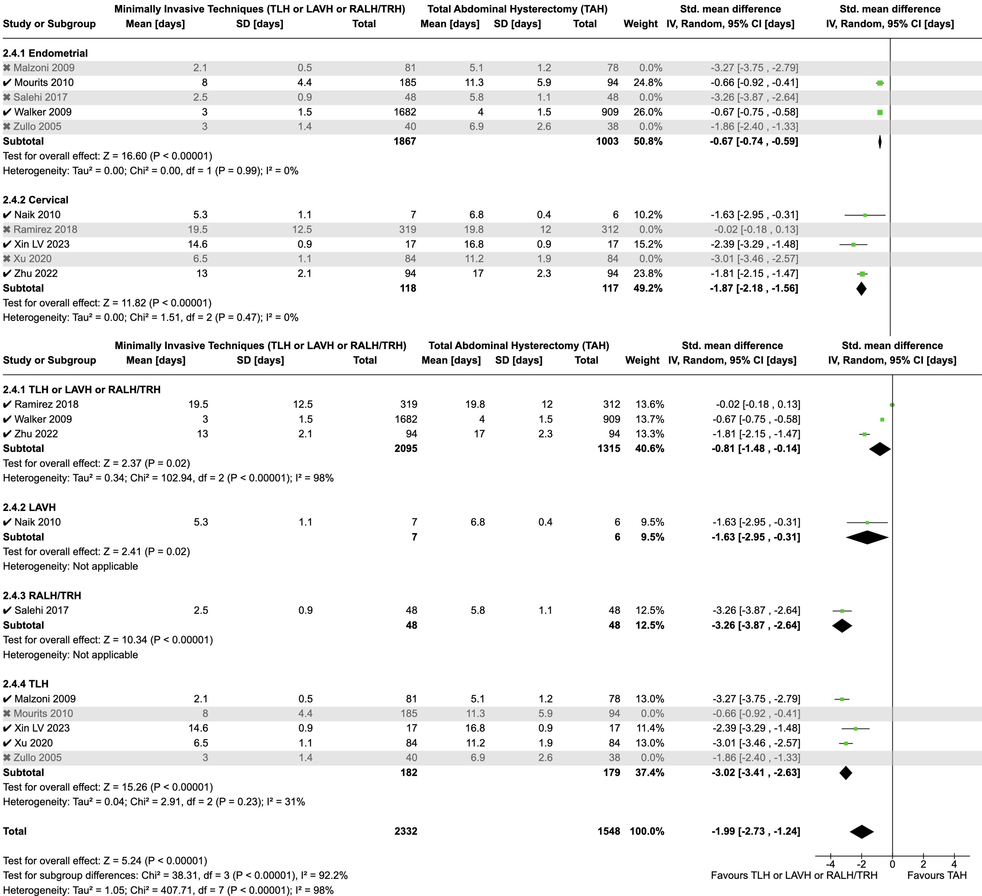
Figure S4. Forest plots regarding Hospitalization Duration per cancer-type and surgery subgroups and for the whole population. Studies highlighted in grey are those excluded during sensitivity analysis since creating non-acceptable statistical heterogeneity (I²≥75%).
Abbreviations: TLH: Total Laparoscopic Hysterectomy; LAVH: Laparoscopically Assisted Vaginal Hysterectomy; RALH/TRH: Robot Assisted Laparoscopic Hysterectomy/Total Robotic Hysterectomy; TAH: Total Abdominal Hysterectomy

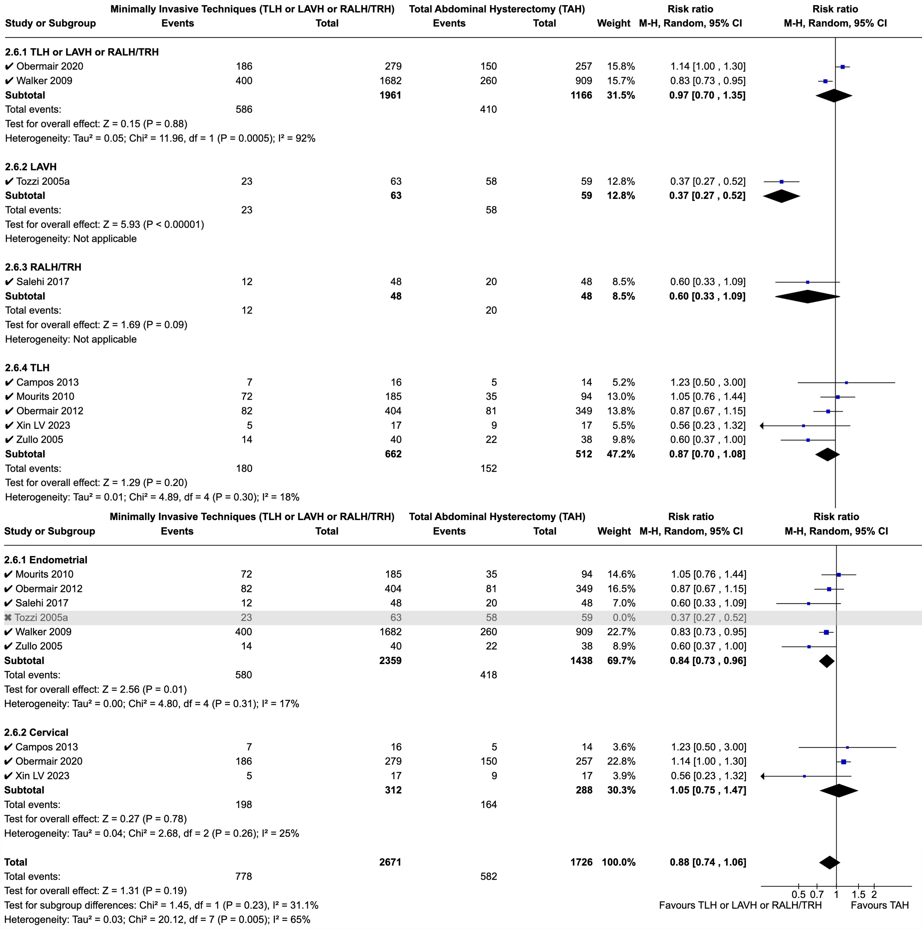
Figure S5. Forest plots regarding Total Number of Complications (intra- and postoperative – number of events) per surgery and cancer-type subgroups and for the whole population. Studies highlighted in grey are those excluded during sensitivity analysis since creating non-acceptable statistical heterogeneity (I²≥75%).
Abbreviations: TLH: Total Laparoscopic Hysterectomy; LAVH: Laparoscopically Assisted Vaginal Hysterectomy; RALH/TRH: Robot Assisted Laparoscopic Hysterectomy/Total Robotic Hysterectomy; TAH: Total Abdominal Hysterectomy

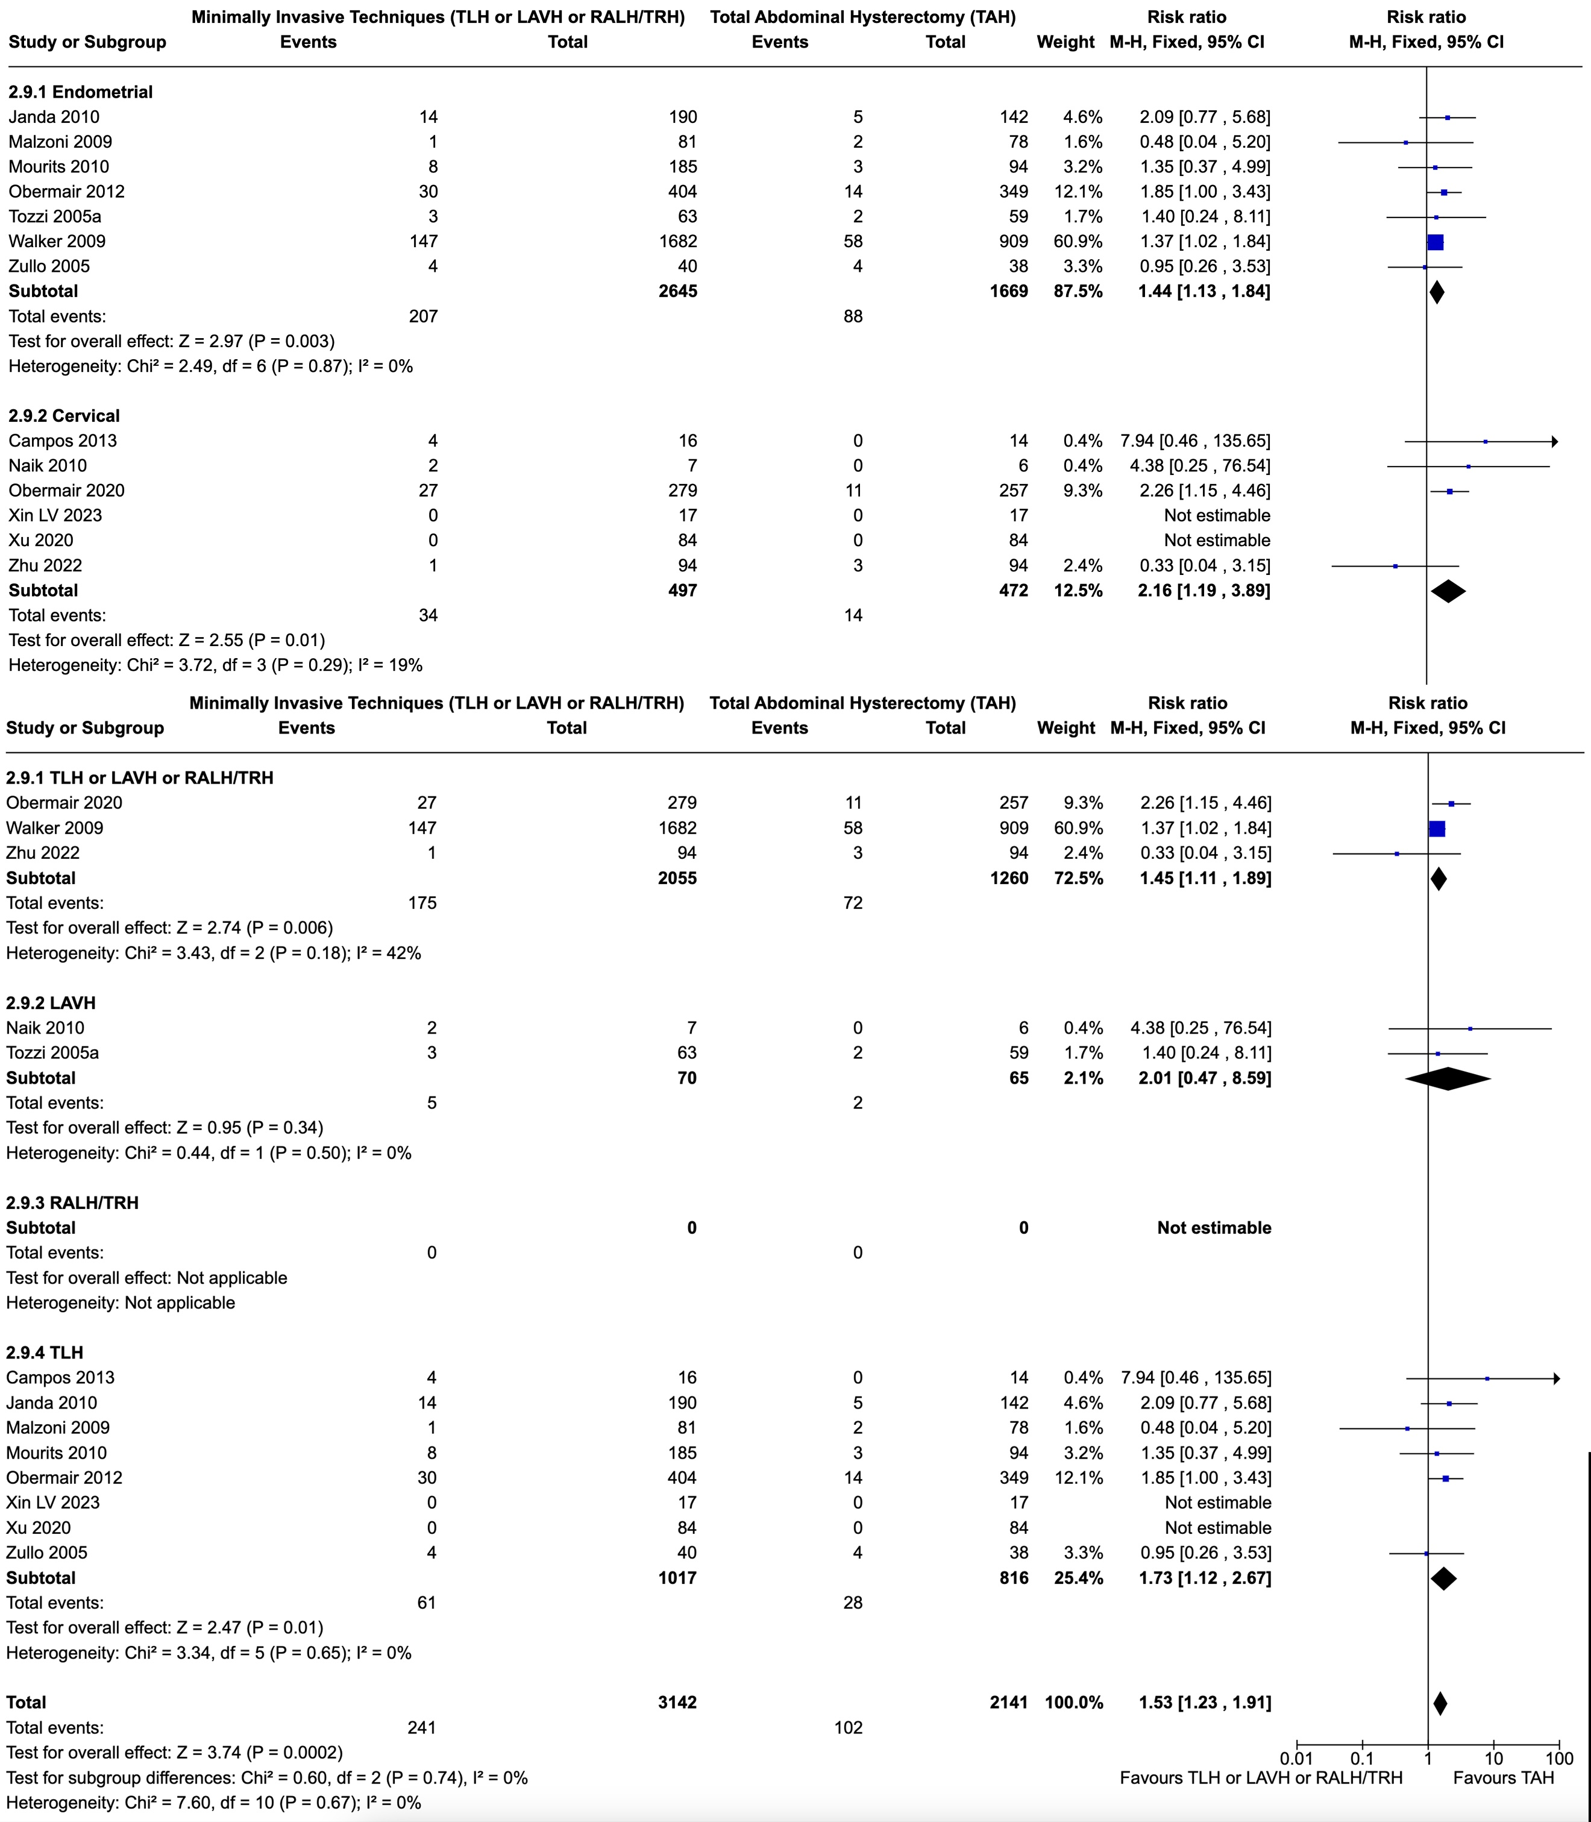
Figure S6. Forest plots regarding Intraoperative Injuries per surgery and cancer-type subgroups and for the whole population.
Abbreviations: TLH: Total Laparoscopic Hysterectomy; LAVH: Laparoscopically Assisted Vaginal Hysterectomy; RALH/TRH: Robot Assisted Laparoscopic Hysterectomy/Total Robotic Hysterectomy; TAH: Total Abdominal Hysterectomy

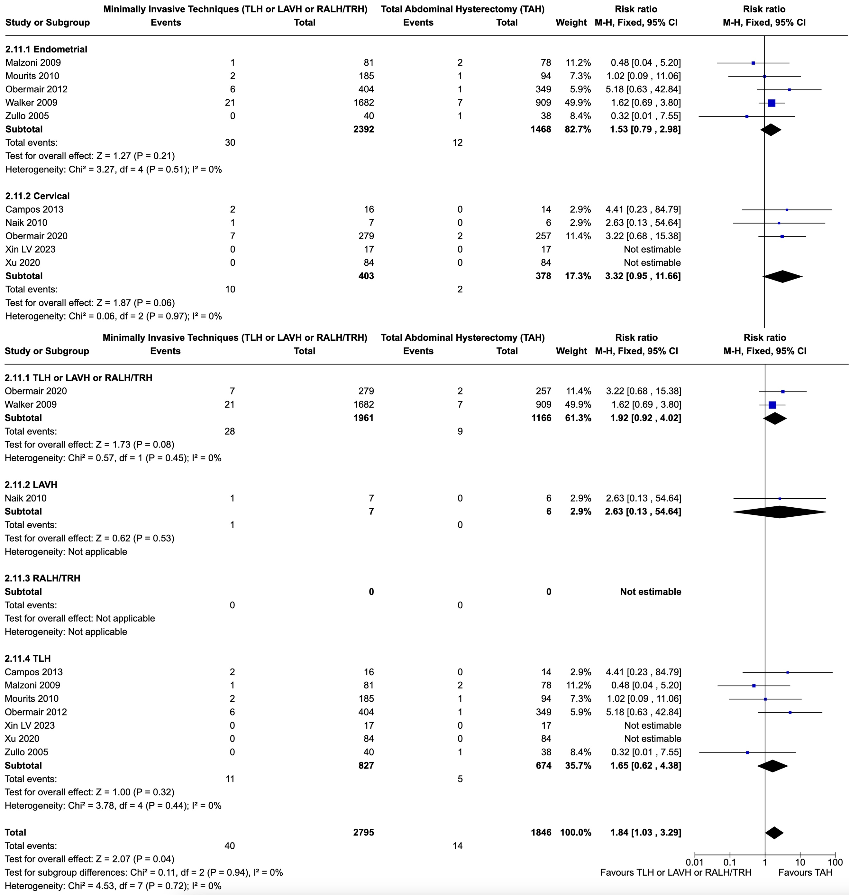
Figure S7. Forest plots regarding Bladder Injury per surgery and cancer-type subgroups and for the whole population.
Abbreviations: TLH: Total Laparoscopic Hysterectomy; LAVH: Laparoscopically Assisted Vaginal Hysterectomy; RALH/TRH: Robot Assisted Laparoscopic Hysterectomy/Total Robotic Hysterectomy; TAH: Total Abdominal Hysterectomy

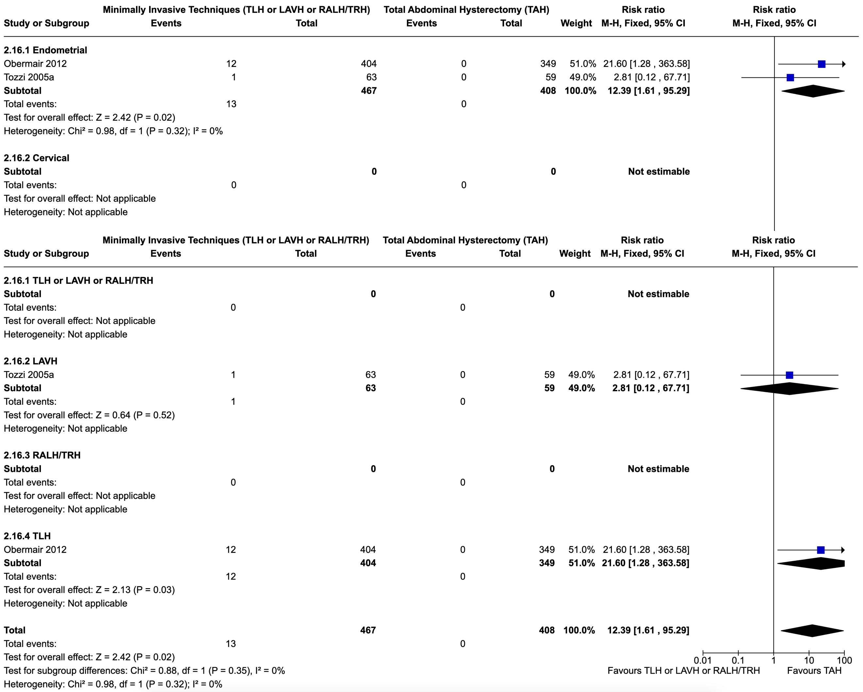
Figure S8. Forest plots regarding Vaginal Injury per surgery and cancer-type subgroups and for the whole population.
Abbreviations: TLH: Total Laparoscopic Hysterectomy; LAVH: Laparoscopically Assisted Vaginal Hysterectomy; RALH/TRH: Robot Assisted Laparoscopic Hysterectomy/Total Robotic Hysterectomy; TAH: Total Abdominal Hysterectomy

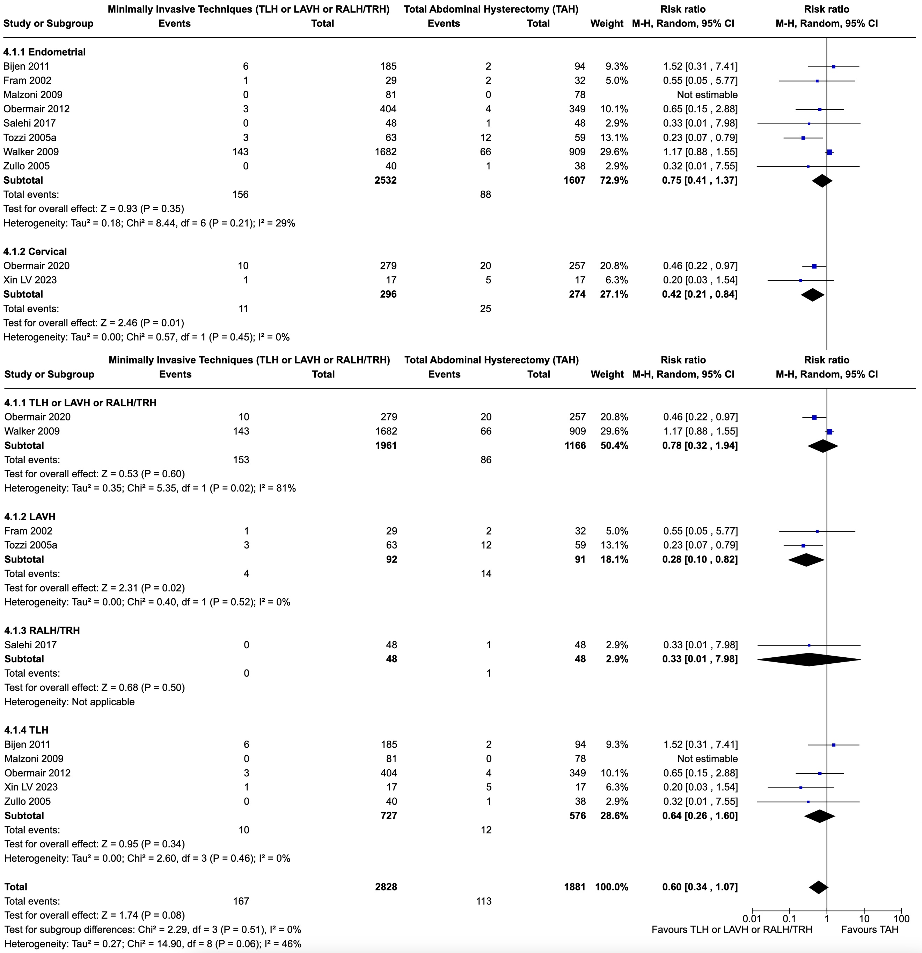
Figure S9. Forest plots regarding Blood Transfusion (intra- and postoperative) per surgery and cancer-type subgroups and for the whole population.
Abbreviations: TLH: Total Laparoscopic Hysterectomy; LAVH: Laparoscopically Assisted Vaginal Hysterectomy; RALH/TRH: Robot Assisted Laparoscopic Hysterectomy/Total Robotic Hysterectomy; TAH: Total Abdominal Hysterectomy

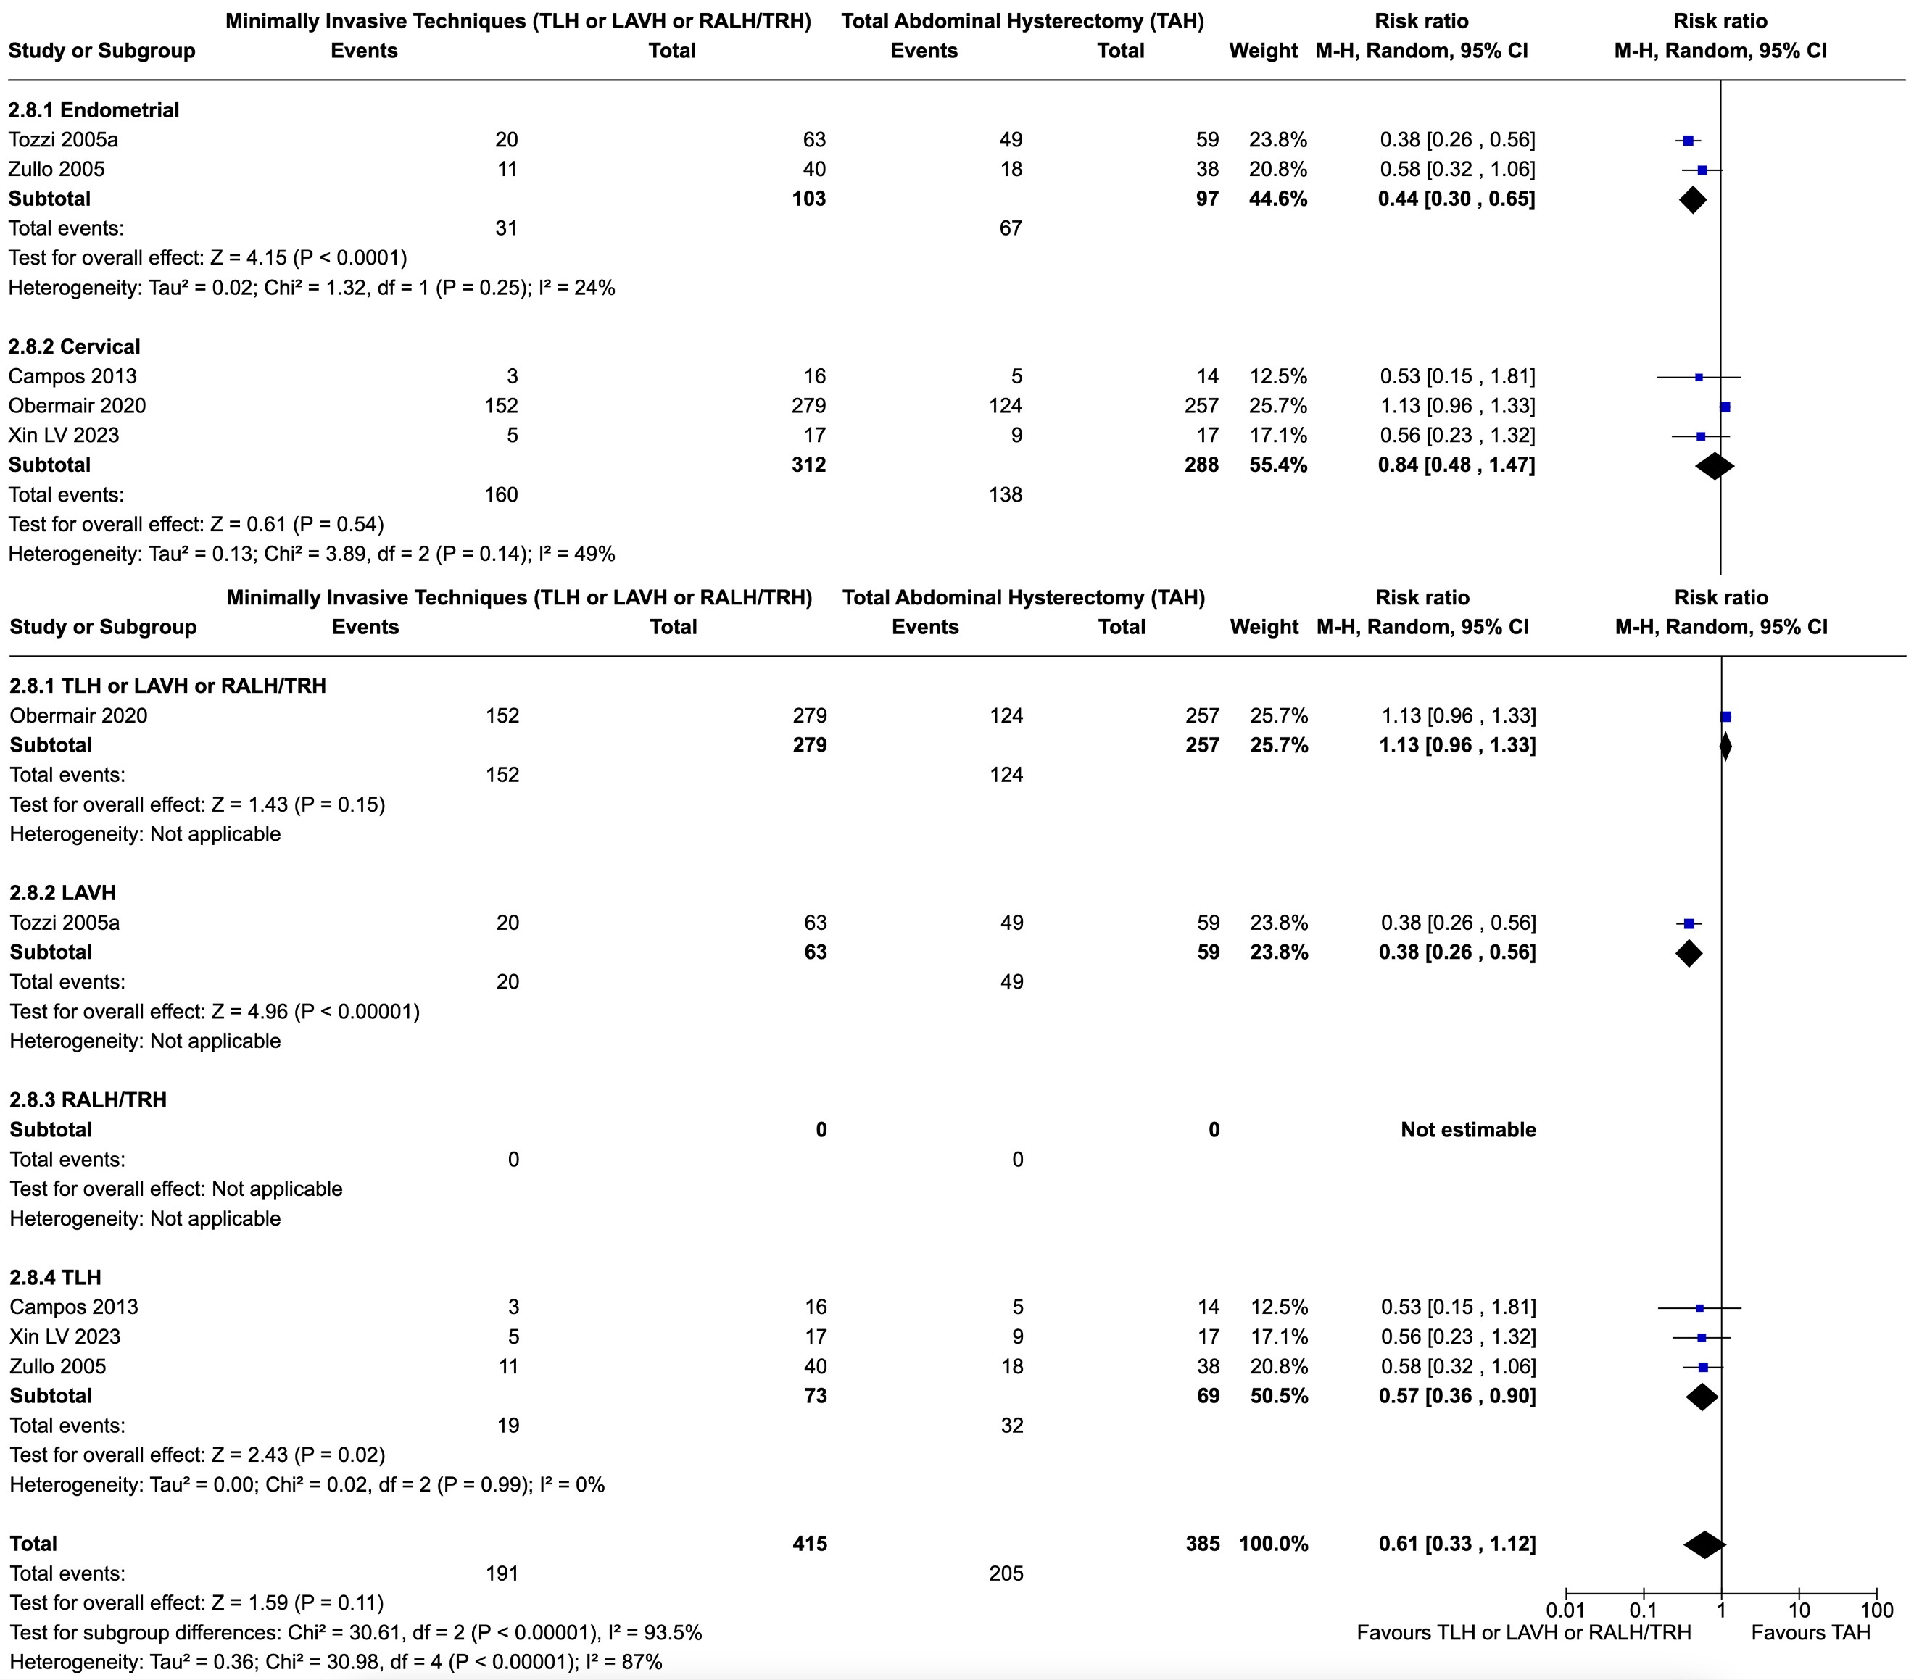
Figure S10. Forest plots regarding Total Number of Postoperative Complications (number of events) per surgery and cancer-type subgroups and for the whole population.
Abbreviations: TLH: Total Laparoscopic Hysterectomy; LAVH: Laparoscopically Assisted Vaginal Hysterectomy; RALH/TRH: Robot Assisted Laparoscopic Hysterectomy/Total Robotic Hysterectomy; TAH: Total Abdominal Hysterectomy

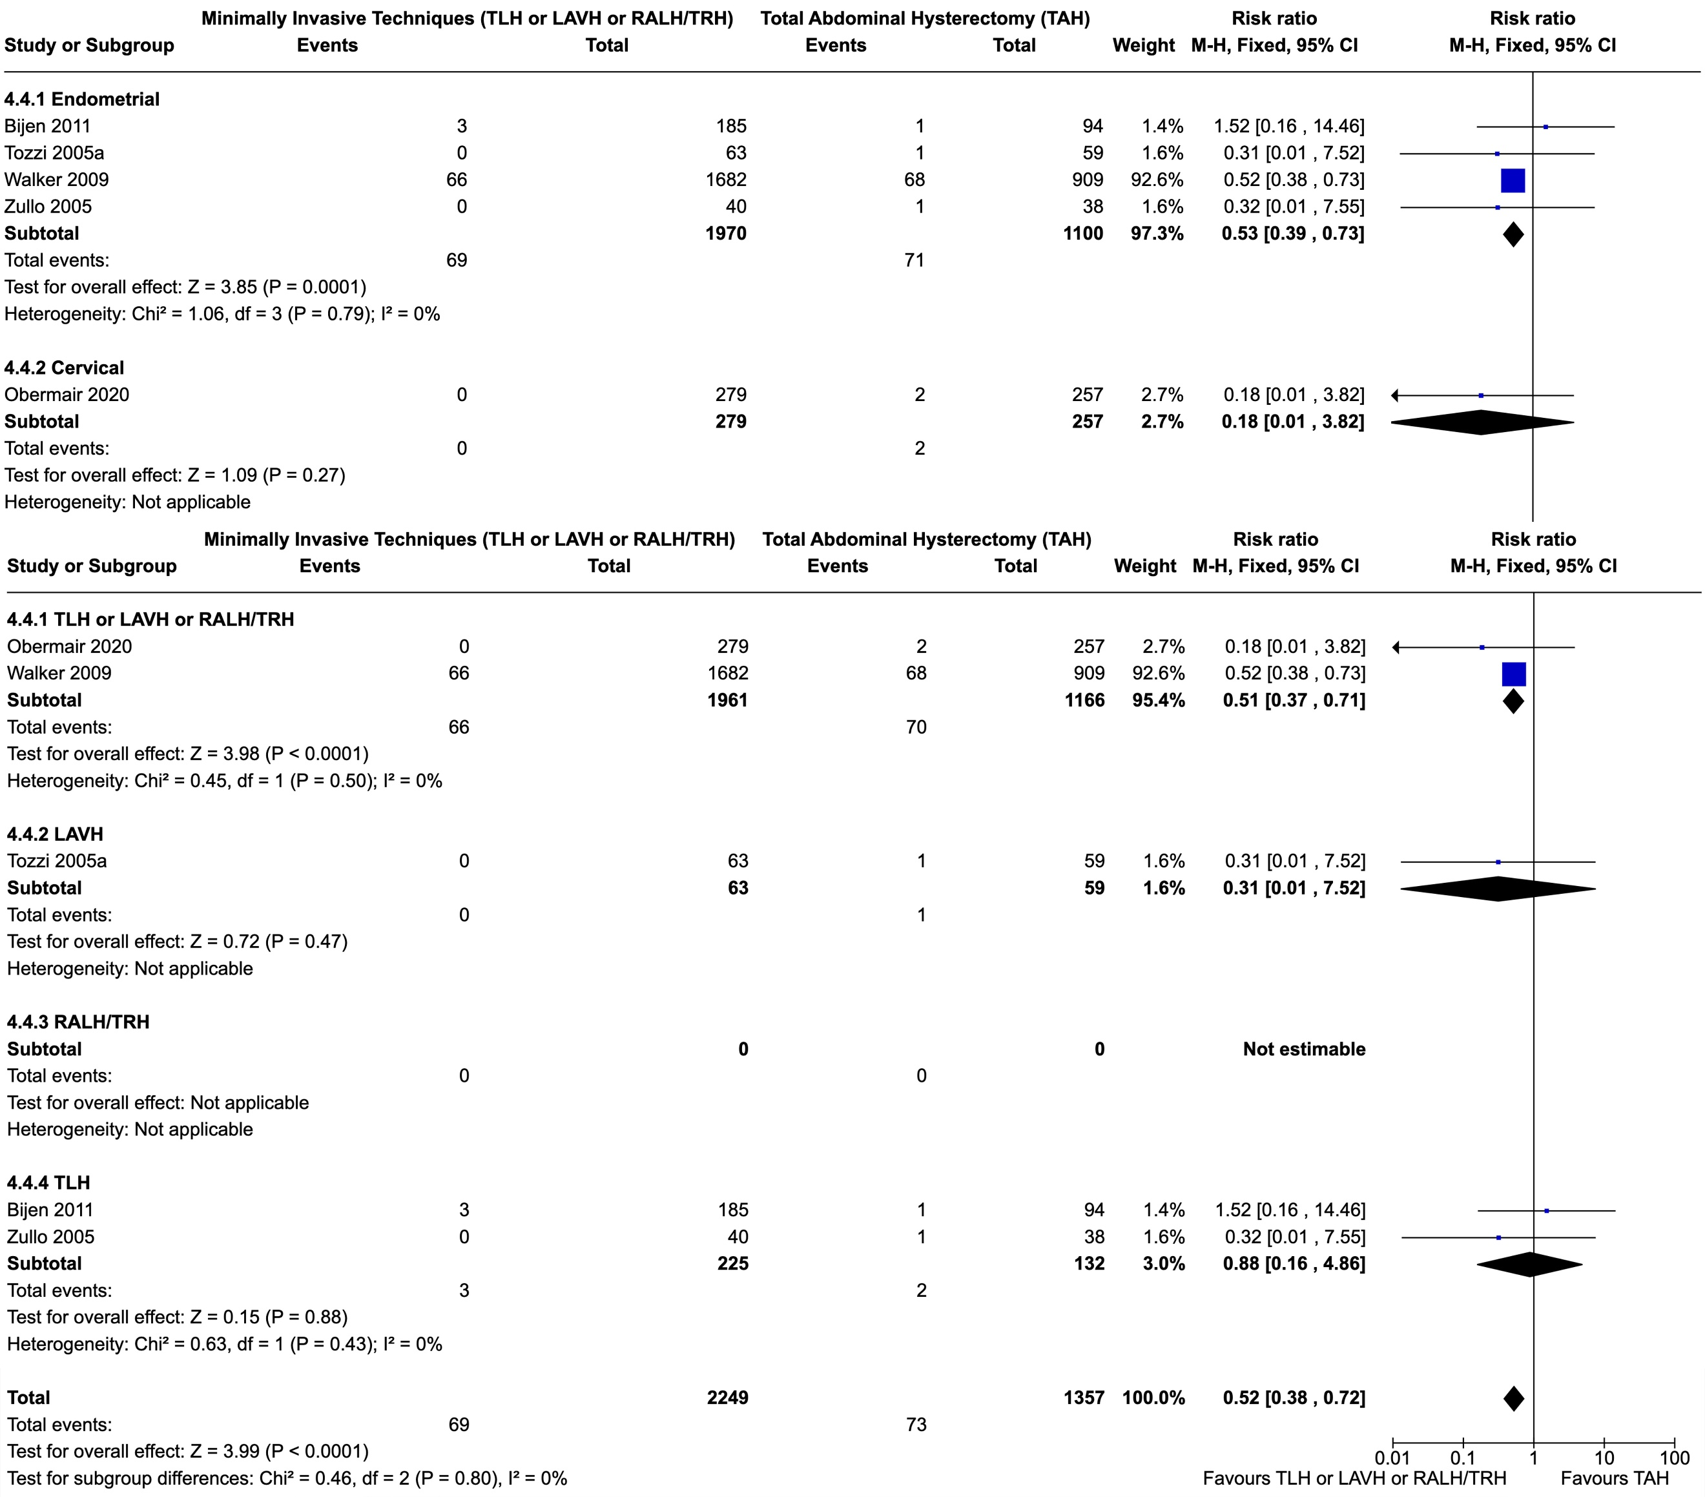
Figure S11. Forest plots regarding Ileus per surgery and cancer-type subgroups and for the whole population.
Abbreviations: TLH: Total Laparoscopic Hysterectomy; LAVH: Laparoscopically Assisted Vaginal Hysterectomy; RALH/TRH: Robot Assisted Laparoscopic Hysterectomy/Total Robotic Hysterectomy; TAH: Total Abdominal Hysterectomy

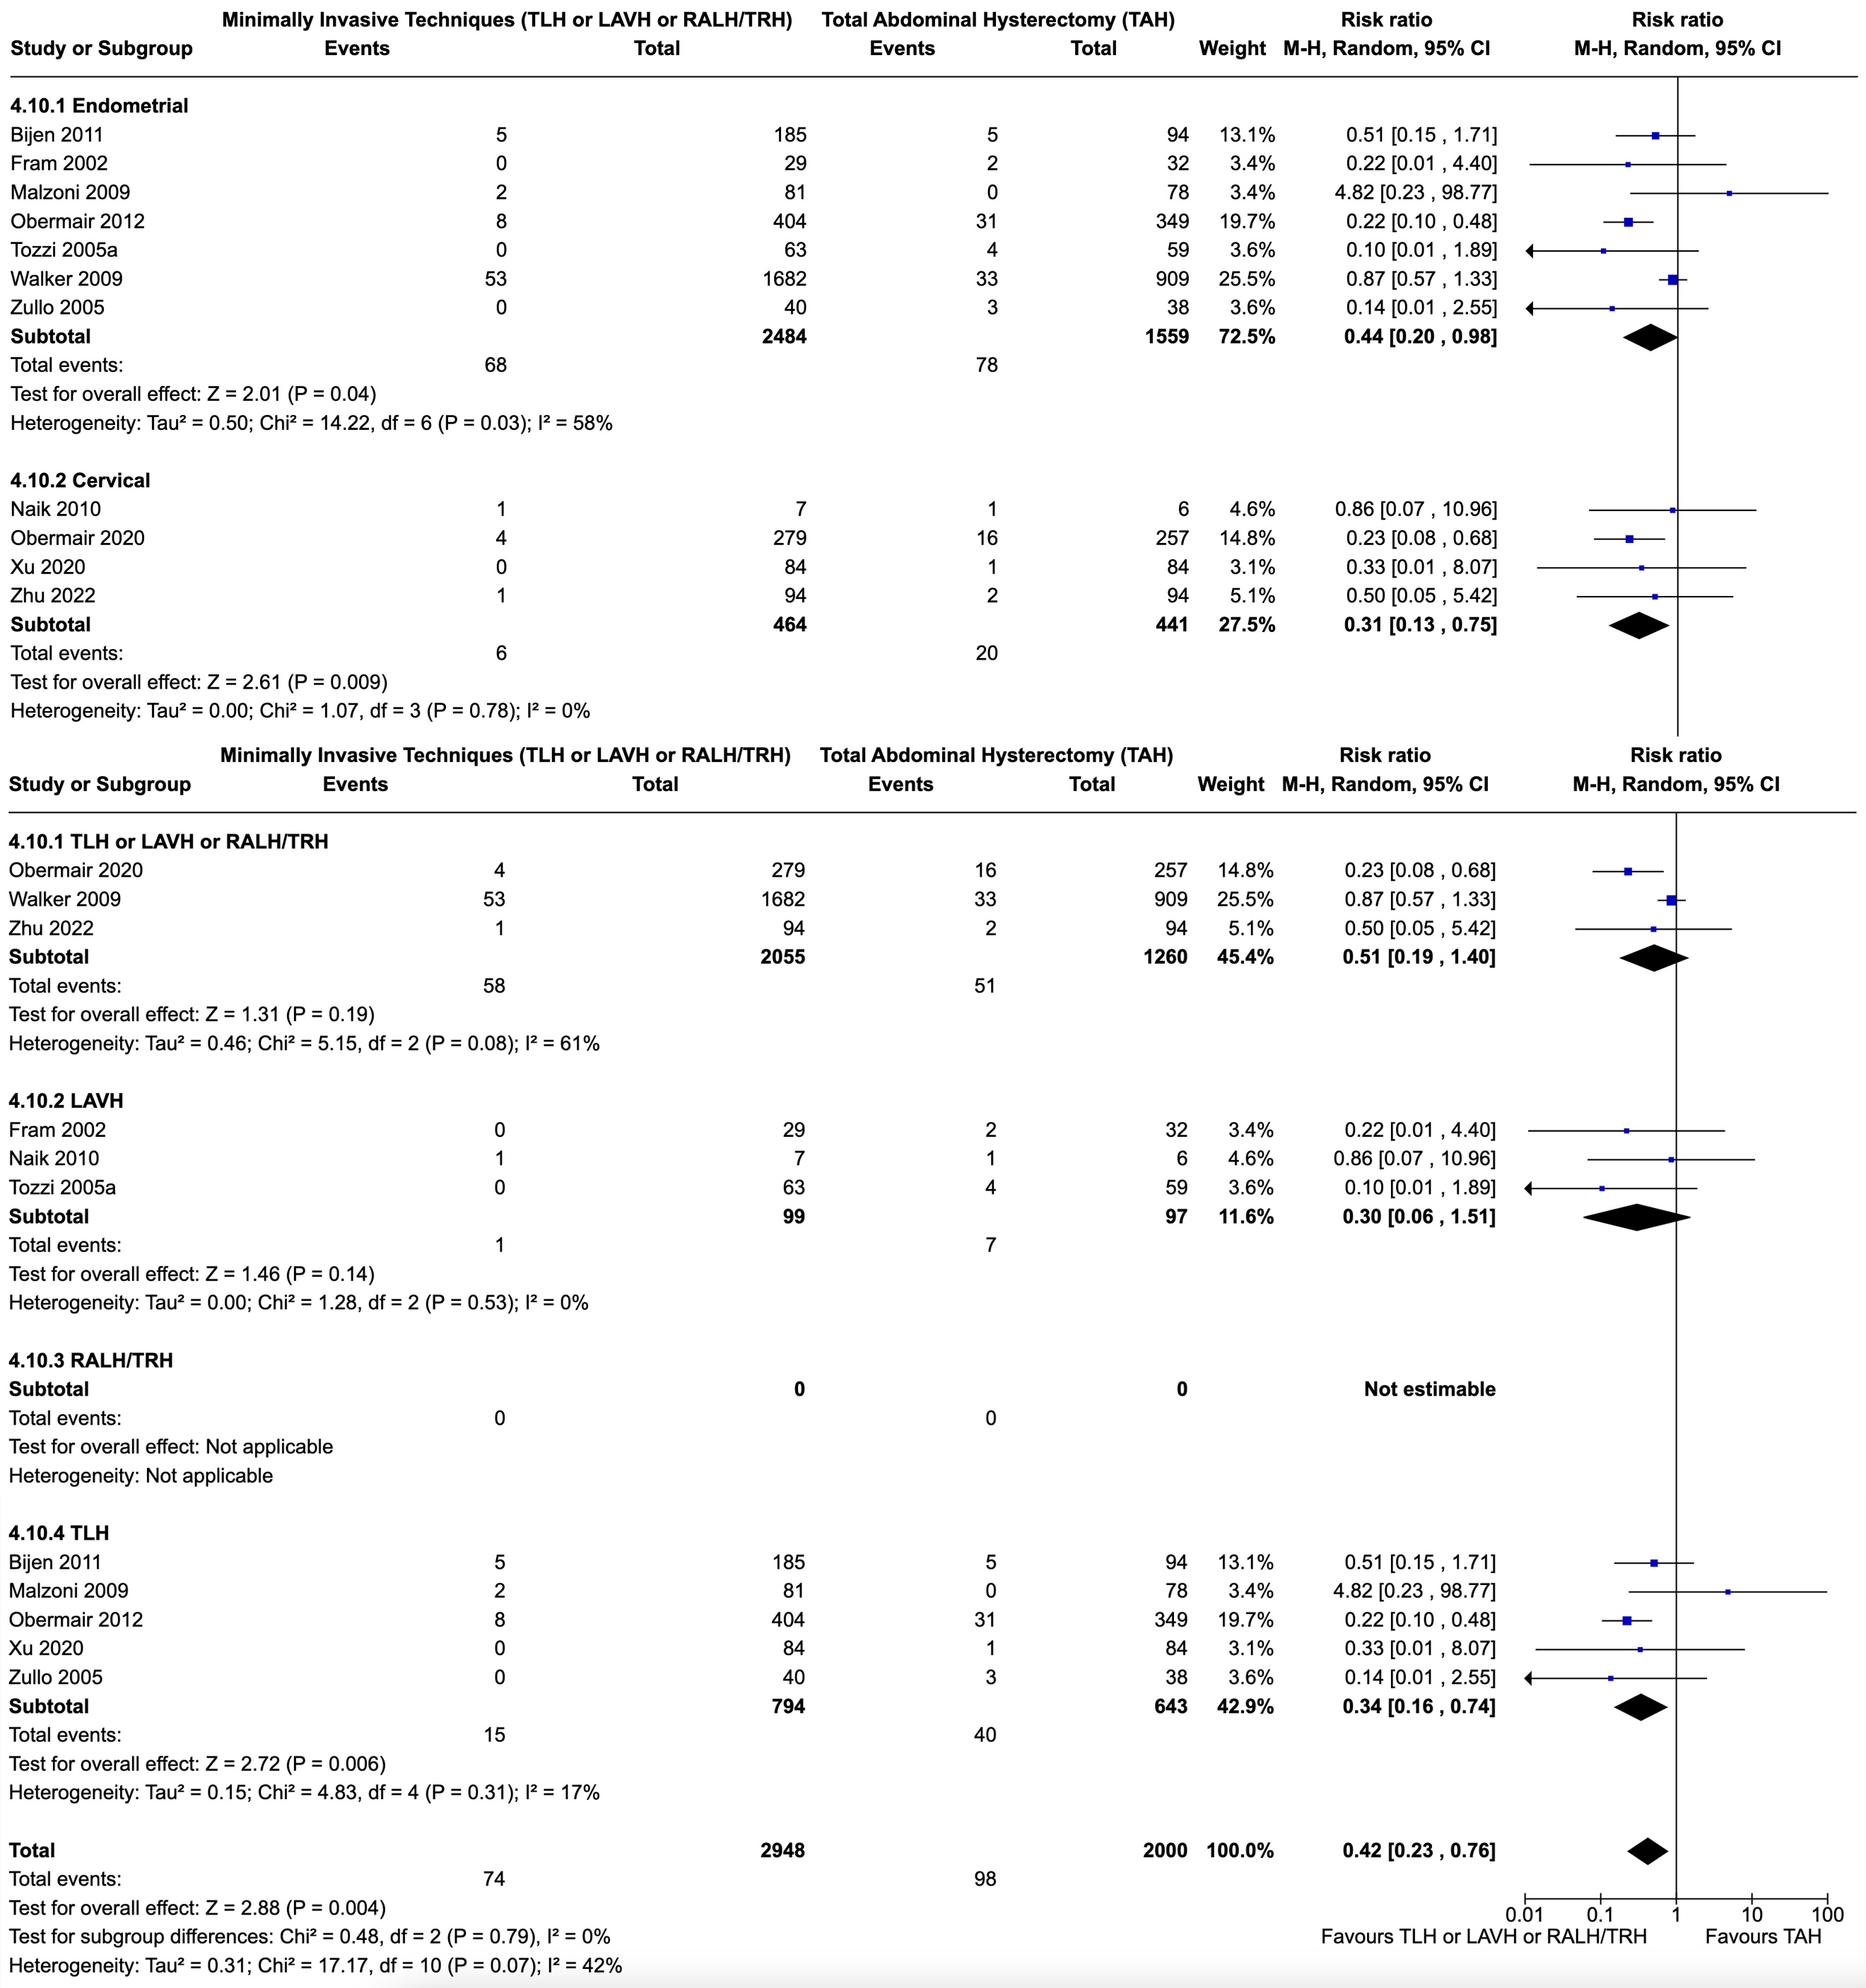
Figure S12. Forest plots regarding Wound Complications per surgery and cancer-type subgroups and for the whole population.
Abbreviations: TLH: Total Laparoscopic Hysterectomy; LAVH: Laparoscopically Assisted Vaginal Hysterectomy; RALH/TRH: Robot Assisted Laparoscopic Hysterectomy/Total Robotic Hysterectomy; TAH: Total Abdominal Hysterectomy

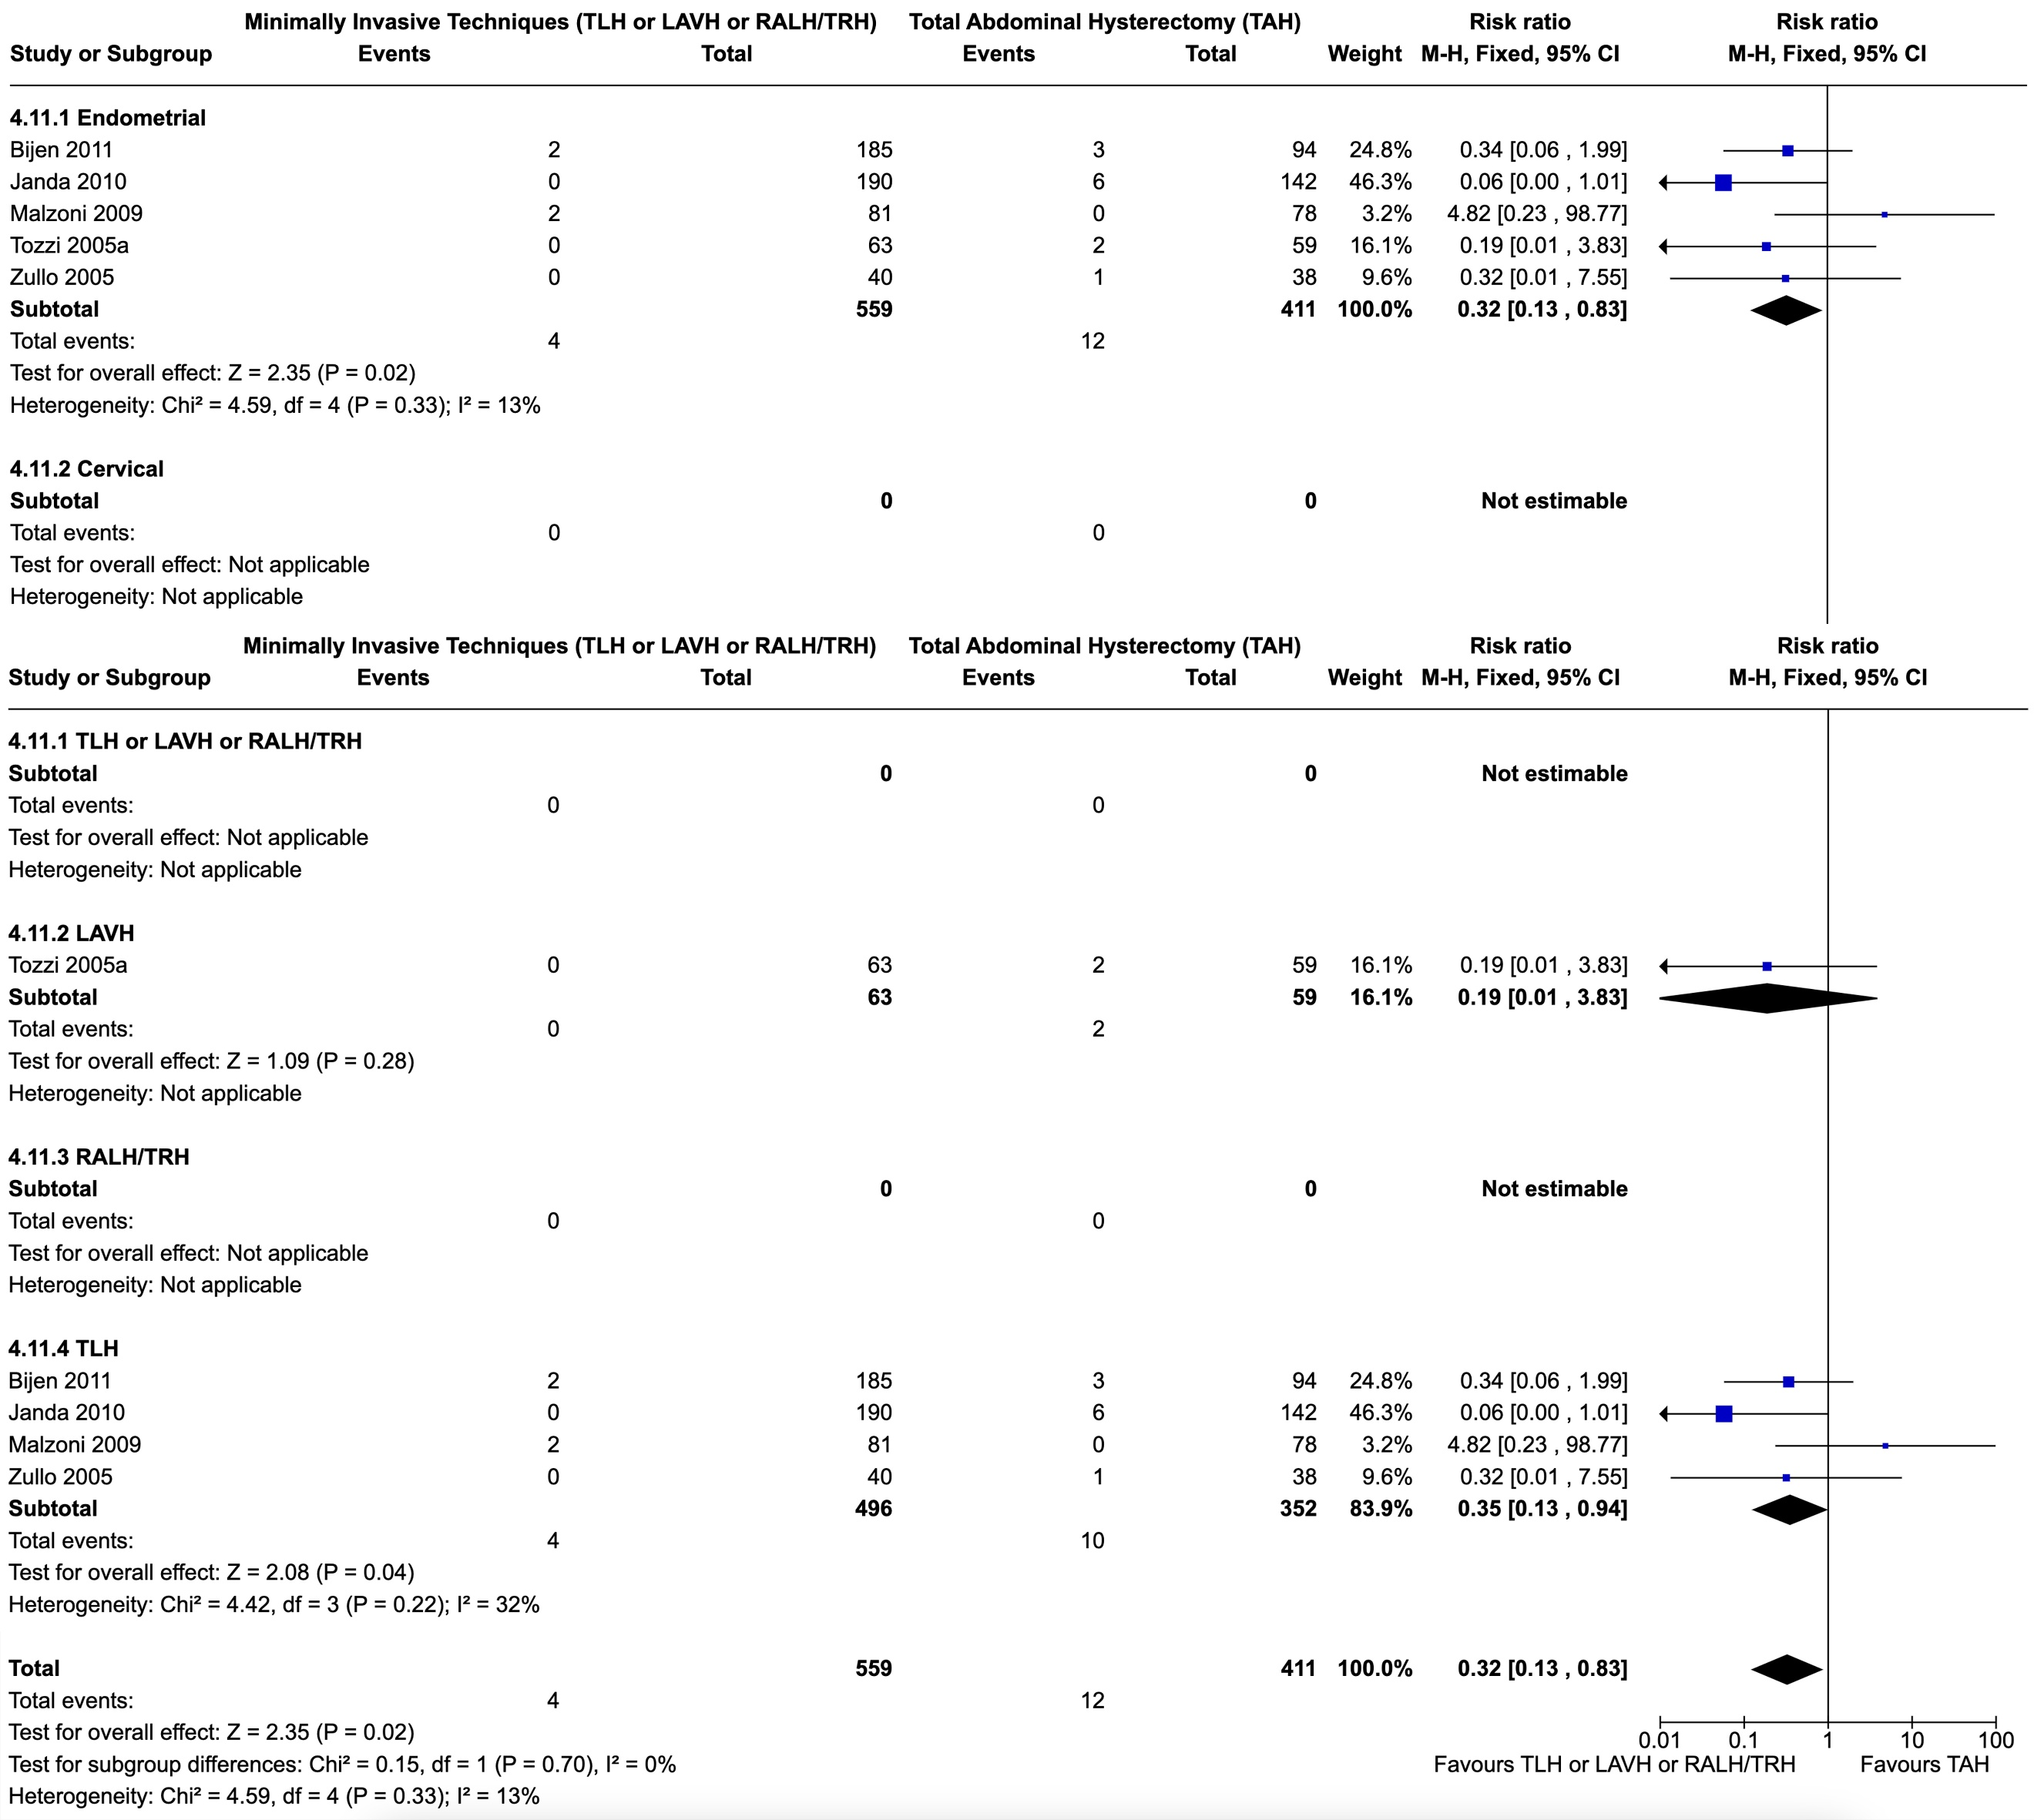
Figure S13. Forest plots regarding Wound Dehiscence per surgery and cancer-type subgroups and for the whole population.
Abbreviations: TLH: Total Laparoscopic Hysterectomy; LAVH: Laparoscopically Assisted Vaginal Hysterectomy; RALH/TRH: Robot Assisted Laparoscopic Hysterectomy/Total Robotic Hysterectomy; TAH: Total Abdominal Hysterectomy

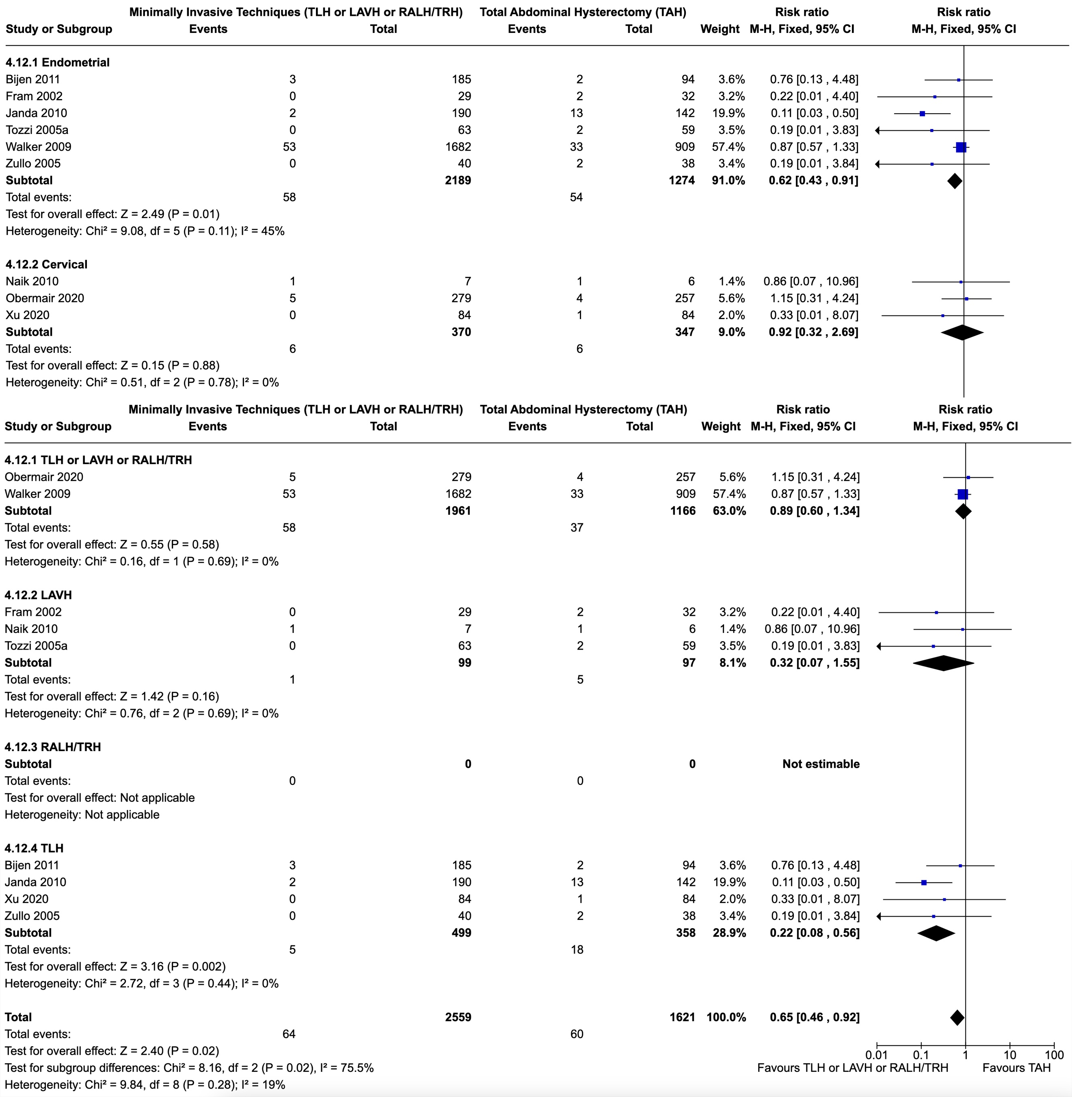
Figure S14. Forest plots regarding Wound Infection per surgery and cancer-type subgroups and for the whole population.
Abbreviations: TLH: Total Laparoscopic Hysterectomy; LAVH: Laparoscopically Assisted Vaginal Hysterectomy; RALH/TRH: Robot Assisted Laparoscopic Hysterectomy/Total Robotic Hysterectomy; TAH: Total Abdominal Hysterectomy

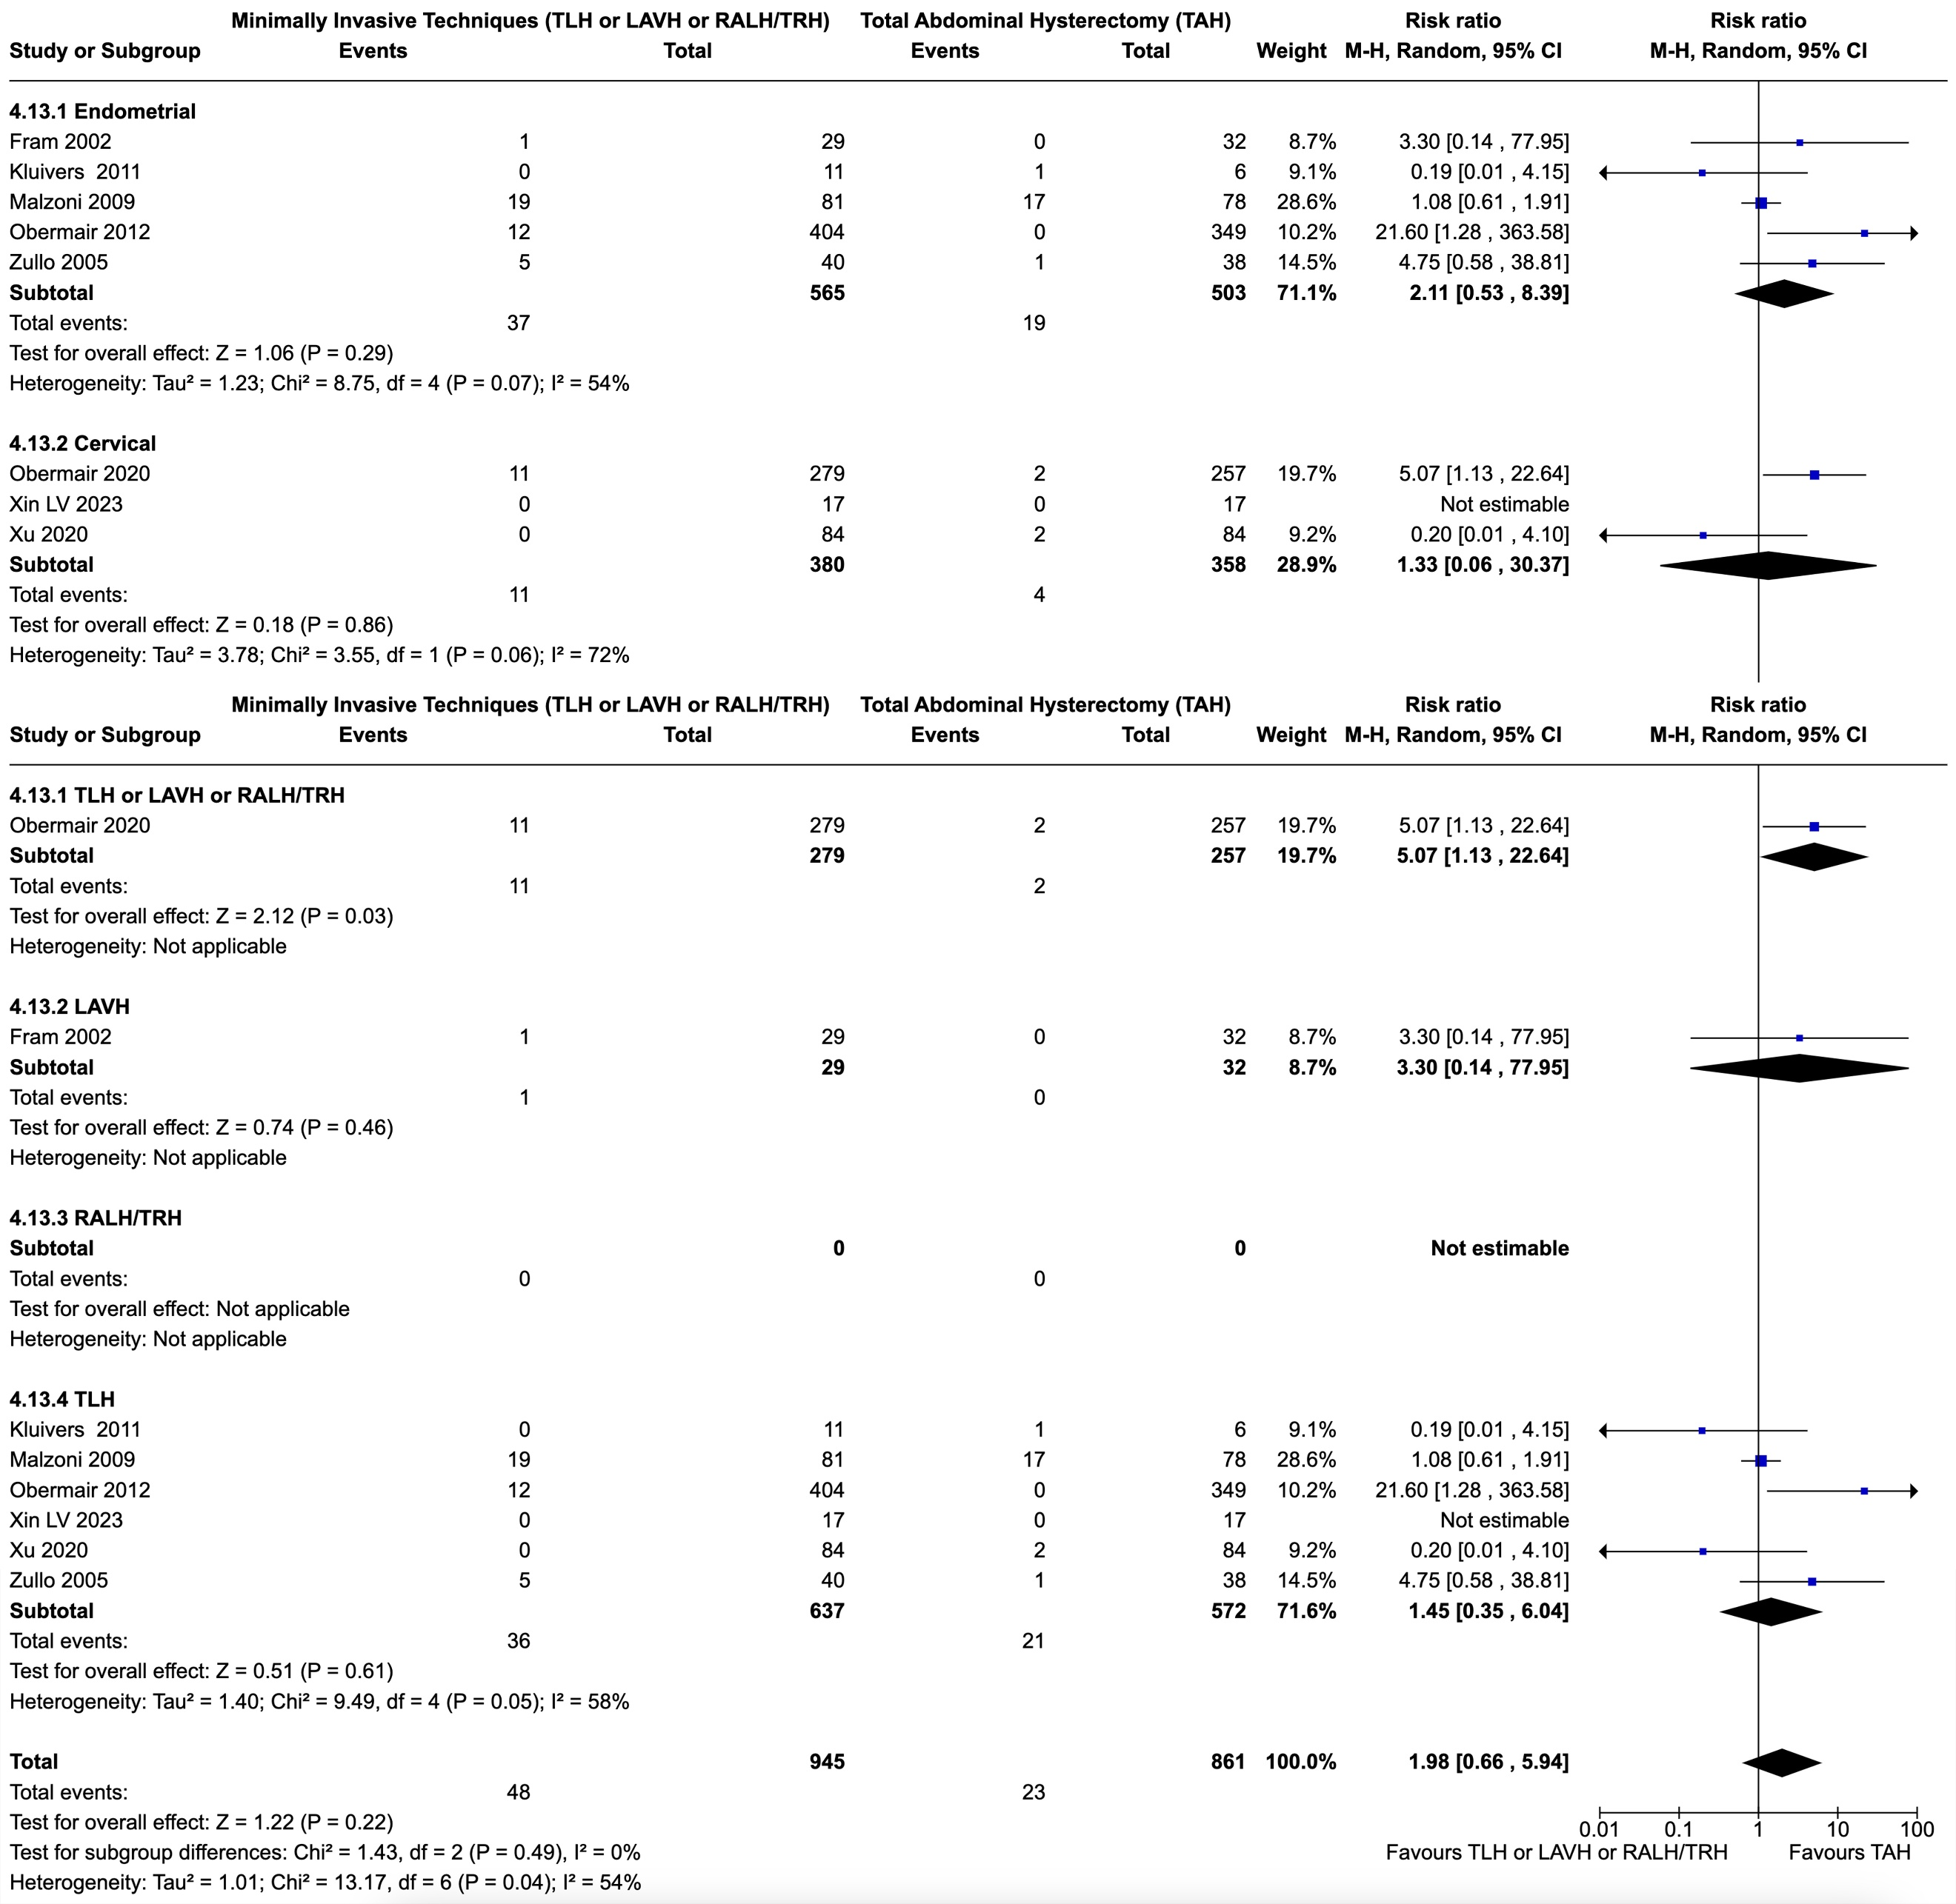
Figure S15. Forest plots regarding Vaginal Vault/Cuff Complications per surgery and cancer-type subgroups and for the whole population.
Abbreviations: TLH: Total Laparoscopic Hysterectomy; LAVH: Laparoscopically Assisted Vaginal Hysterectomy; RALH/TRH: Robot Assisted Laparoscopic Hysterectomy/Total Robotic Hysterectomy; TAH: Total Abdominal Hysterectomy

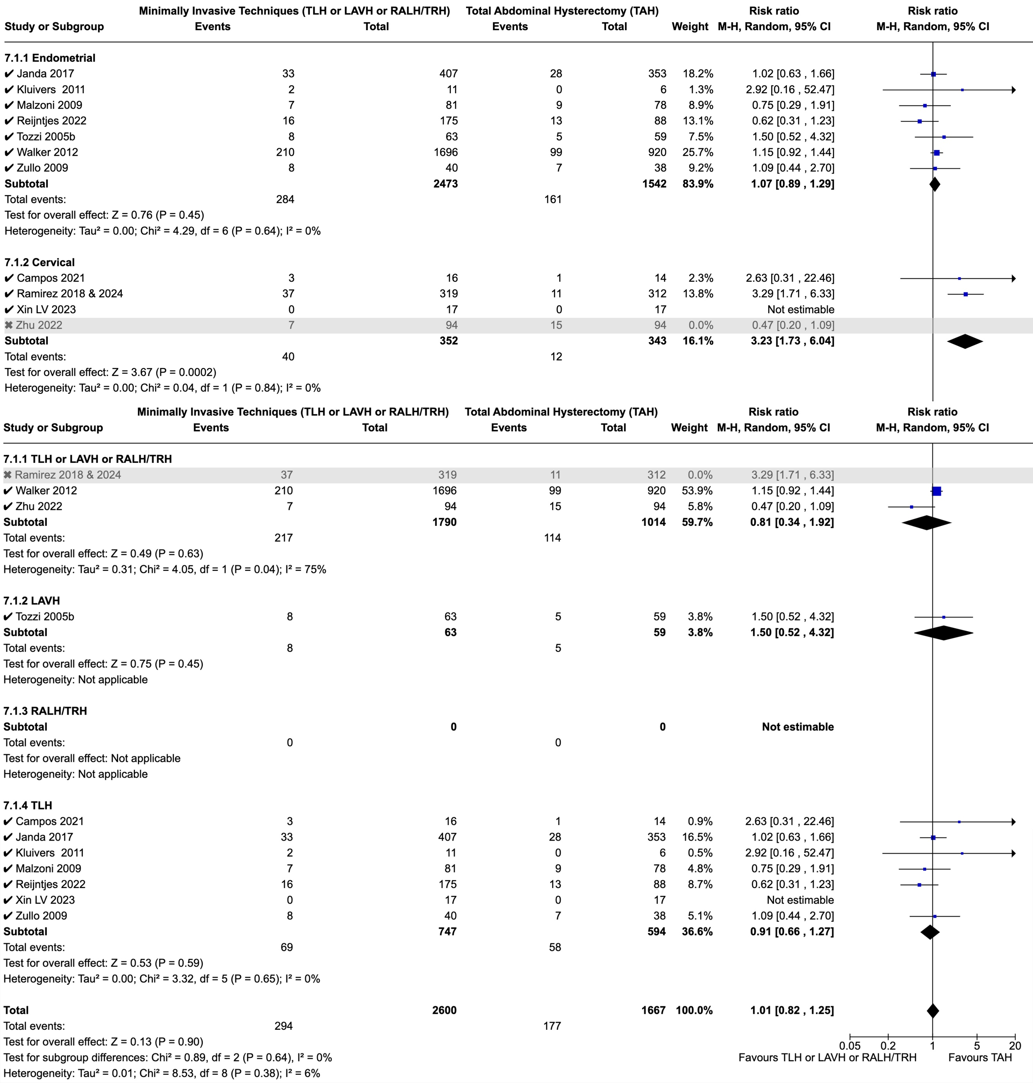
Figure S16. Forest plots regarding Total Recurrence per cancer-type and surgery subgroups and for the whole population. Studies highlighted in grey are those excluded during sensitivity analysis since creating non-acceptable statistical heterogeneity (I²≥75%).
Abbreviations: TLH: Total Laparoscopic Hysterectomy; LAVH: Laparoscopically Assisted Vaginal Hysterectomy; RALH/TRH: Robot Assisted Laparoscopic Hysterectomy/Total Robotic Hysterectomy; TAH: Total Abdominal Hysterectomy

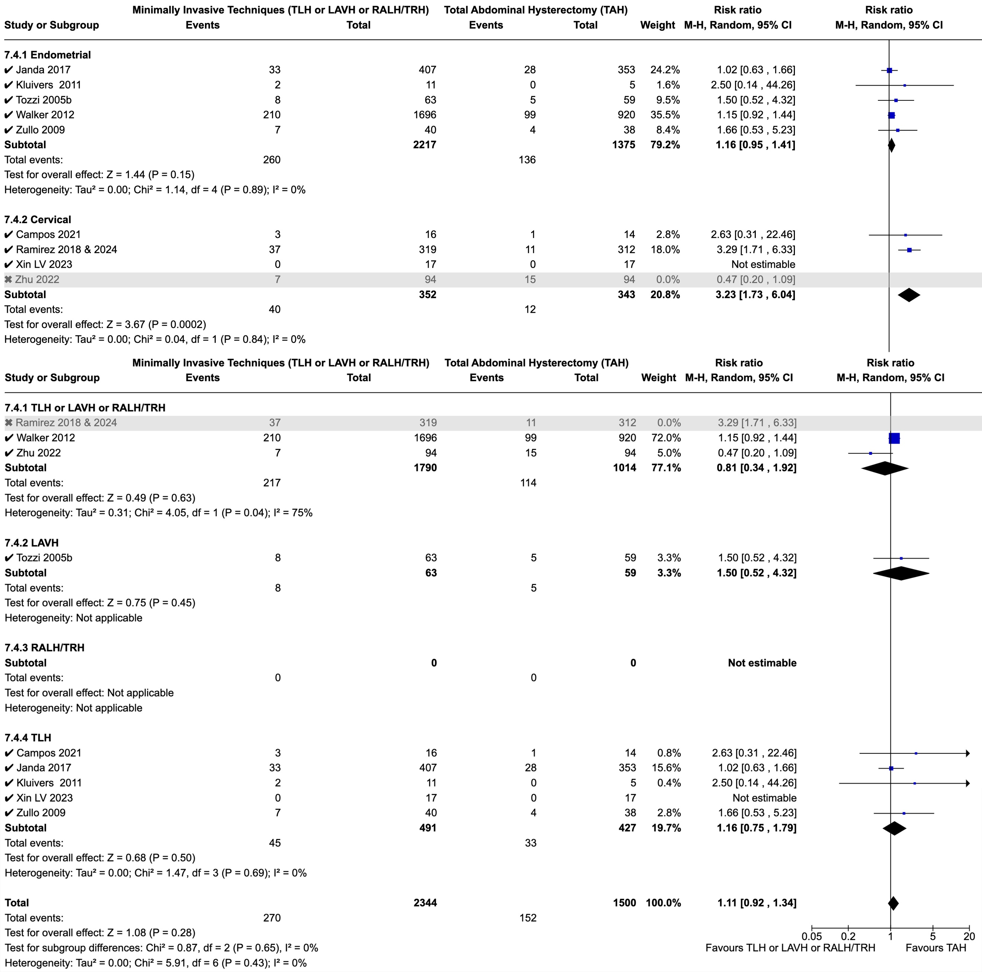
Figure S17. Forest plots regarding 4.5/5-year Recurrence per cancer-type and surgery subgroups and for the whole population. Studies highlighted in grey are those excluded during sensitivity analysis since creating non-acceptable statistical heterogeneity (I²≥75%).
Abbreviations: TLH: Total Laparoscopic Hysterectomy; LAVH: Laparoscopically Assisted Vaginal Hysterectomy; RALH/TRH: Robot Assisted Laparoscopic Hysterectomy/Total Robotic Hysterectomy; TAH: Total Abdominal Hysterectomy

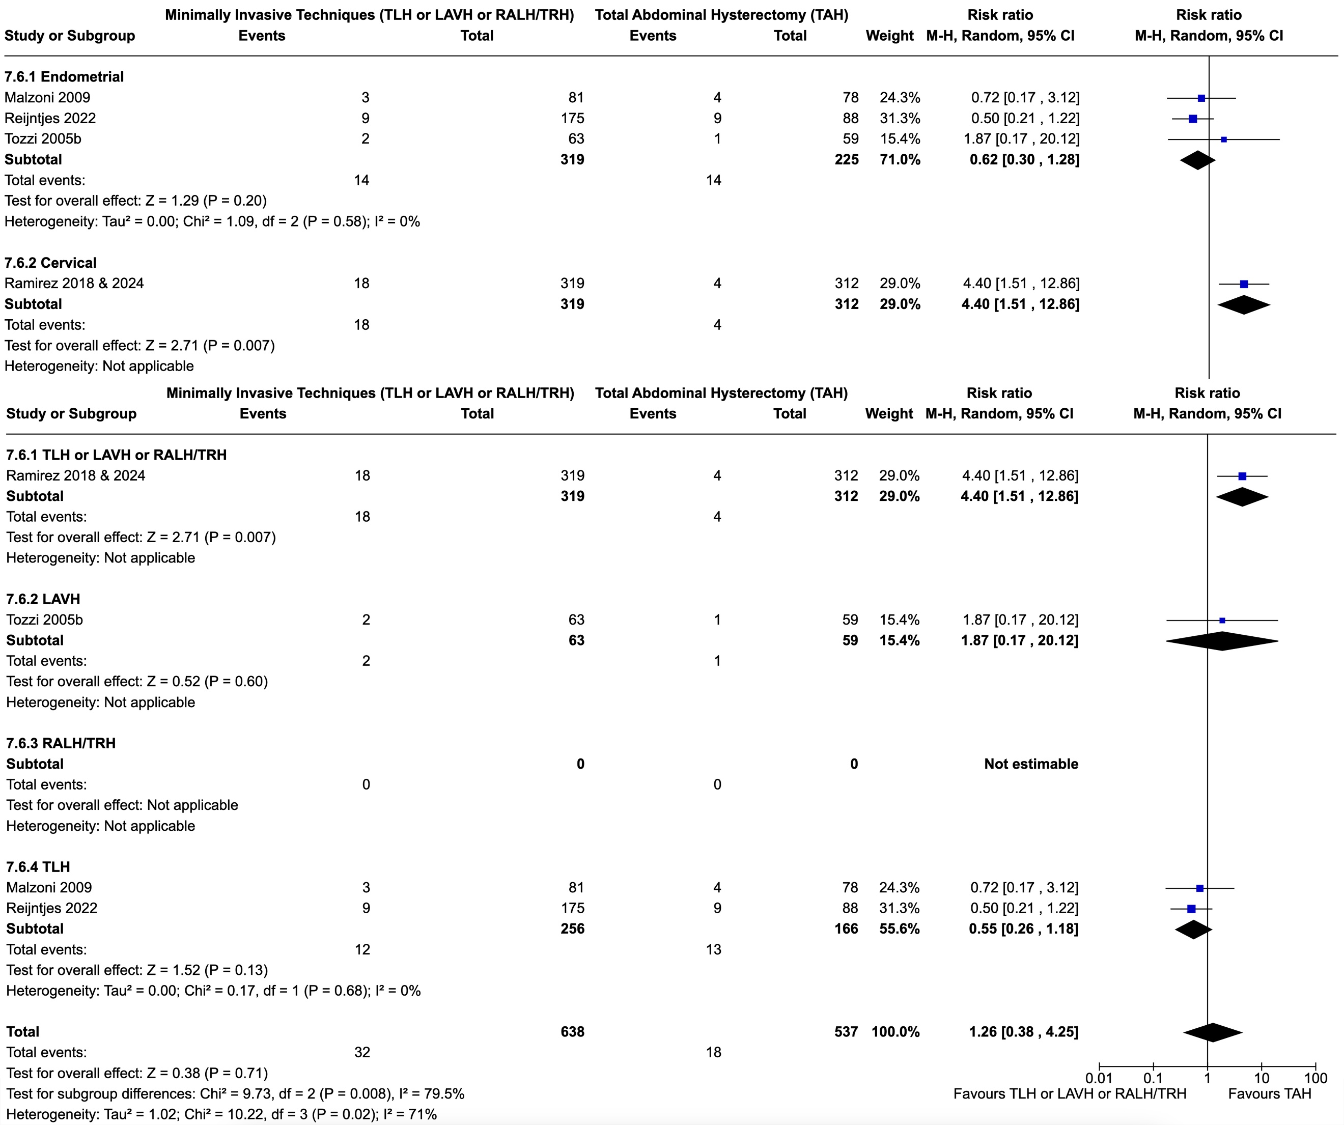
Figure S18. Forest plots regarding Local Recurrence per cancer-type and surgery subgroups and for the whole population.
Abbreviations: TLH: Total Laparoscopic Hysterectomy; LAVH: Laparoscopically Assisted Vaginal Hysterectomy; RALH/TRH: Robot Assisted Laparoscopic Hysterectomy/Total Robotic Hysterectomy; TAH: Total Abdominal Hysterectomy

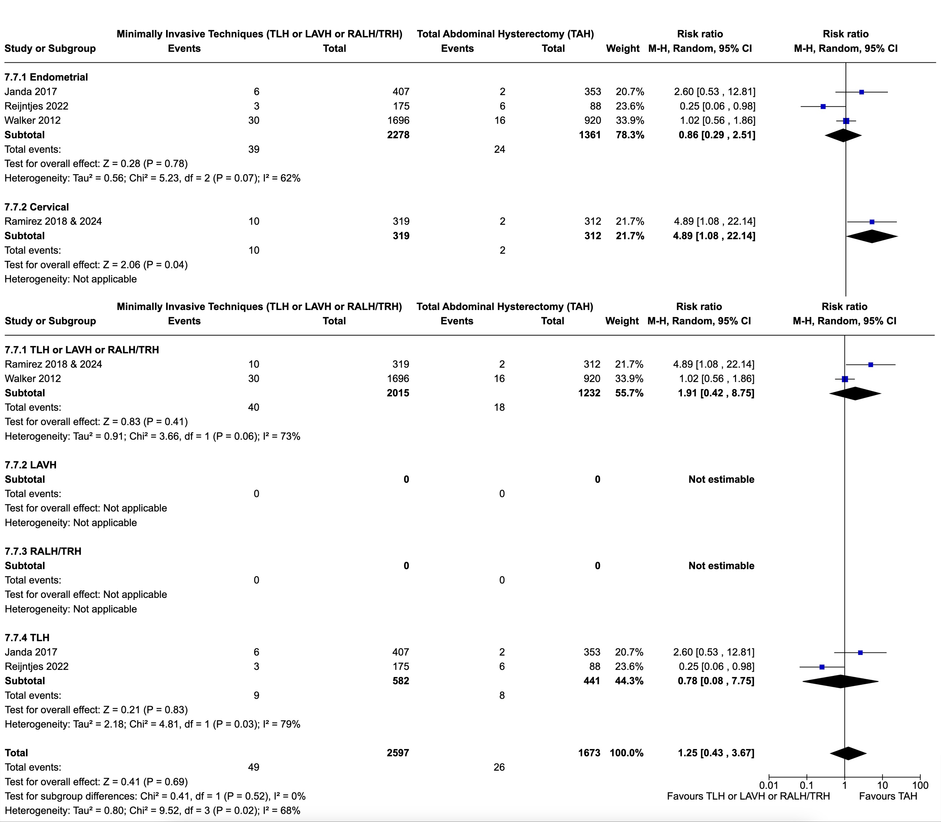
Figure S19. Forest plots regarding Recurrence in Multiple Sites per cancer-type and surgery subgroups and for the whole population.
Abbreviations: TLH: Total Laparoscopic Hysterectomy; LAVH: Laparoscopically Assisted Vaginal Hysterectomy; RALH/TRH: Robot Assisted Laparoscopic Hysterectomy/Total Robotic Hysterectomy; TAH: Total Abdominal Hysterectomy

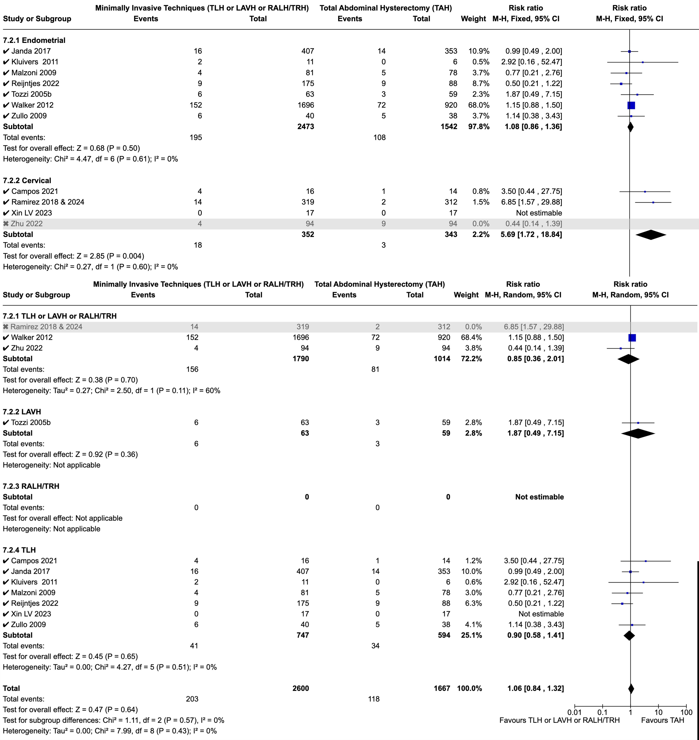
Figure S20. Forest plots regarding Death by Cancer per cancer-type and surgery subgroups and for the whole population. Studies highlighted in grey are those excluded during sensitivity analysis since creating non-acceptable statistical heterogeneity (I²≥75%).
Abbreviations: TLH: Total Laparoscopic Hysterectomy; LAVH: Laparoscopically Assisted Vaginal Hysterectomy; RALH/TRH: Robot Assisted Laparoscopic Hysterectomy/Total Robotic Hysterectomy; TAH: Total Abdominal Hysterectomy

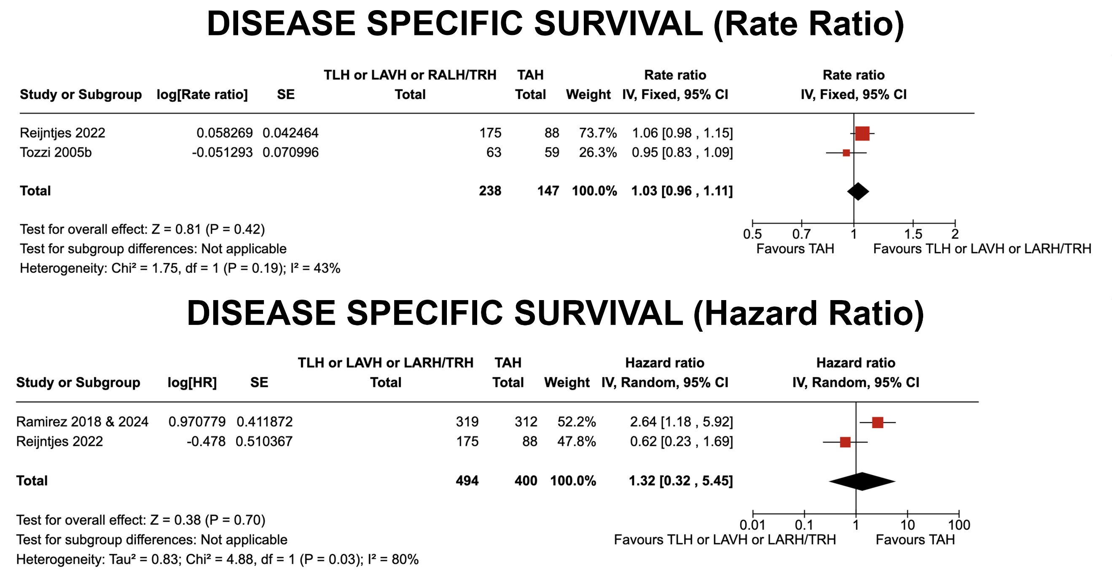
Figure S21. Forest plots regarding Disease Specific Survival Rate Ratio and Hazard Ratio.
Abbreviations: TLH: Total Laparoscopic Hysterectomy; LAVH: Laparoscopically Assisted Vaginal Hysterectomy; RALH/TRH: Robot Assisted Laparoscopic Hysterectomy/Total Robotic Hysterectomy; TAH: Total Abdominal Hysterectomy

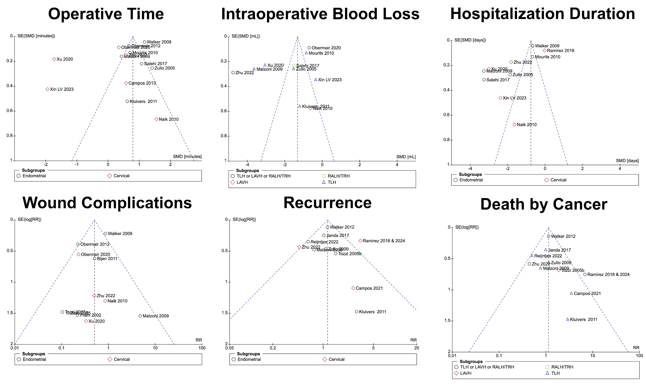
Figure S22. Publication bias was detected for the above outcomes (Operative Time, Intraoperative Blood Loss, Hospitalization Duration, Wound Complications, Recurrence, and Death by Cancer). The funnel plots for these outcomes are shown in this figure.

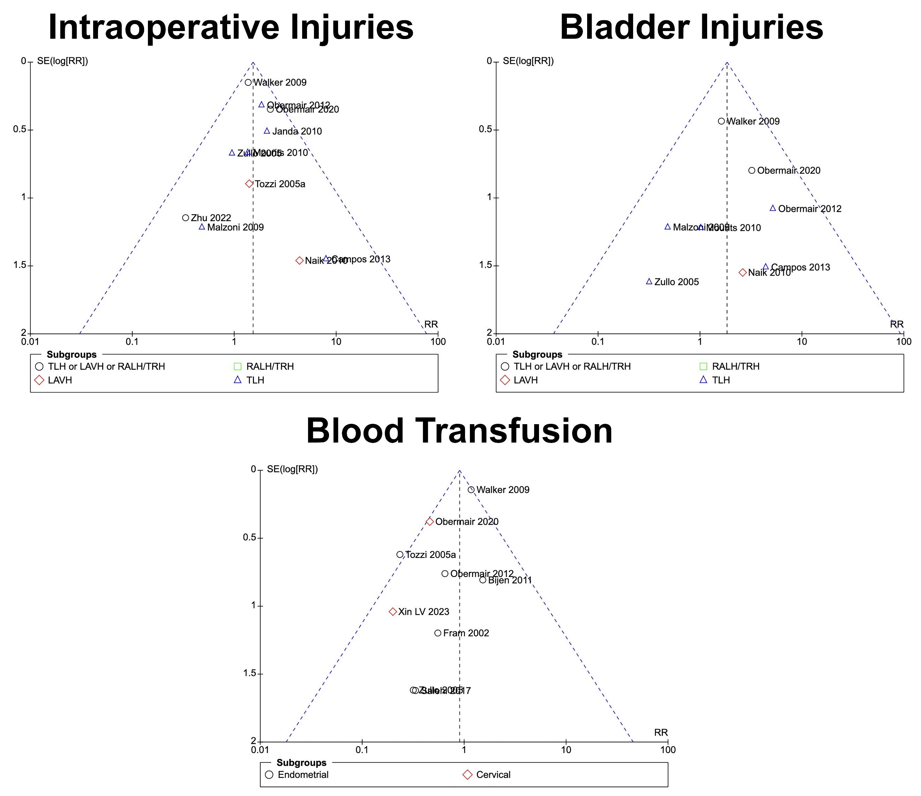
Figure S23. Publication bias was not detected for the above outcomes (Intraoperative Injuries, Bladder Injuries, Blood Transfusion). The funnel plots for these outcomes are shown in this figure.

REFERENCES

1. Malur S, Possover M, Michels W, Schneider A. Laparoscopic-Assisted Vaginal versus Abdominal Surgery in Patients with Endometrial Cancer—A Prospective Randomized Trial. Gynecol Oncol. 2001;80(2):239-244. doi:10.1006/gyno.2000.6069
2. Kondalsamy-Chennakesavan S, Janda M, Gebski V, et al. Risk factors to predict the incidence of surgical adverse events following open or laparoscopic surgery for apparent early stage endometrial cancer: Results from a randomised controlled trial. Eur J Cancer. 2012;48(14):2155-2162. doi:10.1016/j.ejca.2012.03.013
3. Fader AN, Java J, Tenney M, et al. Impact of histology and surgical approach on survival among women with early-stage, high-grade uterine cancer: An NRG Oncology/Gynecologic Oncology Group ancillary analysis. Gynecol Oncol. 2016;143(3):460-465. doi:10.1016/j.ygyno.2016.10.016
4. Bishop EA, Java JJ, Moore KN, Walker JL. Pathologic and Treatment Outcomes Among a Geriatric Population of Endometrial Cancer Patients: An NRG Oncology/Gynecologic Oncology Group Ancillary Data Analysis of LAP2. Int J Gynecol Cancer. 2017;27(4):730-737. doi:10.1097/IGC.0000000000000947
5. Gunderson CC, Java J, Moore KN, Walker JL. The impact of obesity on surgical staging, complications, and survival with uterine cancer: A Gynecologic Oncology Group LAP2 ancillary data study. Gynecol Oncol. 2014;133(1):23-27. doi:10.1016/j.ygyno.2014.01.041
6. Kluivers KB, Mol BWJ, Bremer GL, et al. Pelvic organ function in randomized patients undergoing laparoscopic or abdominal hysterectomy. J Minim Invasive Gynecol. 2007;14(4):442-448. doi:10.1016/j.jmig.2007.02.015
7. Fanfani F, Fagotti A, Gagliardi ML, et al. Minilaparoscopic Versus Single-Port Total Hysterectomy: A Randomized Trial. J Minim Invasive Gynecol. 2013;20(2):192-197. doi:10.1016/j.jmig.2012.11.007
8. Long C, Jang M, Chen S, Chen Y, Su J, Hsu S. Changes in vesicourethral function following laparoscopic hysterectomy versus abdominal hysterectomy. Aust N Z J Obstet Gynaecol. 2002;42(3):259-263. doi:10.1111/j.0004-8666.2002.00259.x
9. Ottosen C, Lingman G, Ottosen L. Three methods for hysterectomy: a randomised, prospective study of short term outcome. BJOG Int J Obstet Gynaecol. 2000;107(11):1380-1385. doi:10.1111/j.1471-0528.2000.tb11652.x
10. Tsai EM, Chen HS, Long CY, et al. Laparoscopically Assisted Vaginal Hysterectomy versus Total Abdominal Hysterectomy: A Study of 100 Cases on Light-Endorsed Transvaginal Section. Gynecol Obstet Invest. 2003;55(2):105-109. doi:10.1159/000070182
11. Deimling TA, Eldridge JL, Riley KA, Kunselman AR, Harkins GJ. Randomized controlled trial comparing operative times between standard and robot‐assisted laparoscopic hysterectomy. Int J Gynecol Obstet. 2017;136(1):64-69. doi:10.1002/ijgo.12001
12. Kornblith AB, Huang HQ, Walker JL, Spirtos NM, Rotmensch J, Cella D. Quality of Life of Patients With Endometrial Cancer Undergoing Laparoscopic International Federation of Gynecology and Obstetrics Staging Compared With Laparotomy: A Gynecologic Oncology Group Study. J Clin Oncol. 2009;27(32):5337-5342. doi:10.1200/JCO.2009.22.3529
13. Frumovitz M, Obermair A, Coleman RL, et al. Quality of life in patients with cervical cancer after open versus minimally invasive radical hysterectomy (LACC): a secondary outcome of a multicentre, randomised, open-label, phase 3, non-inferiority trial. Lancet Oncol. 2020;21(6):851-860. doi:10.1016/S1470-2045(20)30081-4
14. Higgs P, Janda M, Asher R, Gebski V, Forder P, Obermair A. Pelvic floor functional outcomes after total abdominal vs total laparoscopic hysterectomy for endometrial cancer. Am J Obstet Gynecol. 2018;218(4):419.e1-419.e14. doi:10.1016/j.ajog.2017.12.233
15. Fram KM. Laparoscopically assisted vaginal hysterectomy versus abdominal hysterectomy in stage I endometrial cancer. Int J Gynecol Cancer. 2002;12(1):57-61. doi:10.1046/j.1525-1438.2002.01038.x
16. Zorlu CG, Simsek T, Ari ES. Laparoscopy or laparotomy for the management of endometrial cancer. JSLS. 2005;9(4):442-446.
17. Tozzi R, Malur S, Koehler C, Schneider A. Analysis of morbidity in patients with endometrial cancer: is there a commitment to offer laparoscopy? Gynecol Oncol. 2005;97(1):4-9. doi:10.1016/j.ygyno.2004.12.048
18. Tozzi R, Malur S, Koehler C, Schneider A. Laparoscopy versus laparotomy in endometrial cancer: First analysis of survival of a randomized prospective study. J Minim Invasive Gynecol. 2005;12(2):130-136. doi:10.1016/j.jmig.2005.01.021
19. Zullo F, Palomba S, Russo T, et al. A prospective randomized comparison between laparoscopic and laparotomic approaches in women with early stage endometrial cancer: A focus on the quality of life. Am J Obstet Gynecol. 2005;193(4):1344-1352. doi:10.1016/j.ajog.2005.02.131
20. Ghezzi F, Cromi A, Bergamini V, et al. Laparoscopic-assisted vaginal hysterectomy versus total laparoscopic hysterectomy for the management of endometrial cancer: A randomized clinical trial. J Minim Invasive Gynecol. 2006;13(2):114-120. doi:10.1016/j.jmig.2005.11.013
21. Zullo F, Palomba S, Falbo A, et al. Laparoscopic surgery vs laparotomy for early stage endometrial cancer: long-term data of a randomized controlled trial. Am J Obstet Gynecol. 2009;200(3):296.e1-296.e9. doi:10.1016/j.ajog.2008.10.056
22. Walker JL, Piedmonte MR, Spirtos NM, et al. Laparoscopy Compared With Laparotomy for Comprehensive Surgical Staging of Uterine Cancer: Gynecologic Oncology Group Study LAP2. J Clin Oncol. 2009;27(32):5331-5336. doi:10.1200/JCO.2009.22.3248
23. Malzoni M, Tinelli R, Cosentino F, et al. Total laparoscopic hysterectomy versus abdominal hysterectomy with lymphadenectomy for early-stage endometrial cancer: A prospective randomized study. Gynecol Oncol. 2009;112(1):126-133. doi:10.1016/j.ygyno.2008.08.019
24. Janda M, Gebski V, Brand A, et al. Quality of life after total laparoscopic hysterectomy versus total abdominal hysterectomy for stage I endometrial cancer (LACE): a randomised trial. Lancet Oncol. 2010;11(8):772-780. doi:10.1016/S1470-2045(10)70145-5
25. Mourits MJ BCBAHJ ter BHG van der SRPLWJBMYPWJ van der ZAG, de Bock GH, Mourits MJE, et al. Safety of laparoscopy versus laparotomy in early-stage endometrial cancer: a randomised trial. Lancet Oncol. 2010;11(8):763-771. doi:10.1016/S1470-2045(10)70143-1
26. Bijen CBM, de Bock GH, Vermeulen KM, et al. Laparoscopic hysterectomy is preferred over laparotomy in early endometrial cancer patients, however not cost effective in the very obese. Eur J Cancer. 2011;47(14):2158-2165. doi:10.1016/j.ejca.2011.04.035
27. Kluivers KB, Ten Cate FA, Bongers MY, Brölmann HAM, Hendriks JCM. Total laparoscopic hysterectomy versus total abdominal hysterectomy with bilateral salpingo-oophorectomy for endometrial carcinoma: a randomised controlled trial with 5-year follow-up. Gynecol Surg. 2011;8(4):427-434. doi:10.1007/s10397-011-0668-6
28. Walker JL, Piedmonte MR, Spirtos NM, et al. Recurrence and Survival After Random Assignment to Laparoscopy Versus Laparotomy for Comprehensive Surgical Staging of Uterine Cancer: Gynecologic Oncology Group LAP2 Study. J Clin Oncol. 2012;30(7):695-700. doi:10.1200/JCO.2011.38.8645
29. Obermair A, Janda M, Baker J, et al. Improved surgical safety after laparoscopic compared to open surgery for apparent early stage endometrial cancer: Results from a randomised controlled trial. Eur J Cancer. 2012;48(8):1147-1153. doi:10.1016/j.ejca.2012.02.055
30. Mäenpää MM, Nieminen K, Tomás EI, Laurila M, Luukkaala TH, Mäenpää JU. Robotic-assisted vs traditional laparoscopic surgery for endometrial cancer: a randomized controlled trial. Am J Obstet Gynecol. 2016;215(5):588.e1-588.e7. doi:10.1016/j.ajog.2016.06.005
31. Salehi S, Åvall-Lundqvist E, Legerstam B, Carlson JW, Falconer H. Robot-assisted laparoscopy versus laparotomy for infrarenal paraaortic lymphadenectomy in women with high-risk endometrial cancer: A randomised controlled trial. Eur J Cancer. 2017;79:81-89. doi:10.1016/j.ejca.2017.03.038
32. Janda M, Gebski V, Davies LC, et al. Effect of Total Laparoscopic Hysterectomy vs Total Abdominal Hysterectomy on Disease-Free Survival Among Women With Stage I Endometrial Cancer: A Randomized Clinical Trial. JAMA. 2017;317(12):1224-1233. doi:10.1001/jama.2017.2068
33. Reijntjes B, van Suijlichem M, Woolderink JM, et al. Recurrence and survival after laparoscopy versus laparotomy without lymphadenectomy in early-stage endometrial cancer: long-term outcomes of a randomised trial. Gynecol Oncol. 2022;164(2):265-270. doi:10.1016/j.ygyno.2021.12.019
34. Naik R, Jackson K, Lopes A, Cross P, Henry J. Laparoscopic assisted radical vaginal hysterectomy versus radical abdominal hysterectomy—a randomised phase II trial: perioperative outcomes and surgicopathological measurements. BJOG Int J Obstet Gynaecol. 2010;117(6):746-751. doi:10.1111/j.1471-0528.2010.02479.x
35. Campos L, Francisco Limberger L, Tetelbom Stein A, Nocchi Kalil A. Postoperative pain and perioperative outcomes after laparoscopic radical hysterectomy and abdominal radical hysterectomy in patients with early cervical cancer: a randomised controlled trial. Trials. 2013;14(1):293. doi:10.1186/1745-6215-14-293
36. Luo C, Liu M, Li X. Efficacy and safety outcomes of robotic radical hysterectomy in Chinese older women with cervical cancer compared with laparoscopic radical hysterectomy. BMC Womens Health. 2018;18(1):61. doi:10.1186/s12905-018-0544-x
37. Ramirez PT, Frumovitz M, Pareja R, et al. Minimally Invasive versus Abdominal Radical Hysterectomy for Cervical Cancer. N Engl J Med. 2018;379(20):1895-1904. doi:10.1056/NEJMoa1806395
38. Xu Q, Dong M, Dong W, et al. Postoperative comparison of laparoscopic radical resection and open abdominal radical hysterectomy for cervical cancer patient. Arch Gynecol Obstet. 2020;302(2):473-479. doi:10.1007/s00404-020-05606-2
39. Obermair A, Asher R, Pareja R, et al. Incidence of adverse events in minimally invasive vs open radical hysterectomy in early cervical cancer: results of a randomized controlled trial. Am J Obstet Gynecol. 2020;222(3):249.e1-249.e10. doi:10.1016/j.ajog.2019.09.036
40. Campos L, Limberger LF, Stein A, Caldas JM. Survival after Laparoscopic versus Abdominal Radical Hysterectomy in Early Cervical Cancer: A Randomized Controlled Trial. Asian Pac J Cancer Prev. 2021;22(1):93-97. doi:10.31557/APJCP.2021.22.1.93
41. Zhu H, Yan Y, Liu Y, Meng L. The Impact of Minimally Invasive Surgery on Treating Patients with Early Cervical Adenocarcinoma. J Invest Surg. 2022;35(7):1593-1601. doi:10.1080/08941939.2022.2064009
42. Lv X, Ding B, Xu J, Shen Y. Effect of modified radical laparoscopic hysterectomy versus open radical hysterectomy on short-term clinical outcomes in early-stage cervical cancer: a single-center, prospective, randomized controlled trial. World J Surg Oncol. 2023;21(1):167. doi:10.1186/s12957-023-03044-3
43. Ramirez PT, Robledo KP, Frumovitz M, et al. LACC Trial: Final Analysis on Overall Survival Comparing Open Versus Minimally Invasive Radical Hysterectomy for Early-Stage Cervical Cancer. J Clin Oncol. 2024;42(23):2741-2746. doi:10.1200/JCO.23.02335
44. Hongge Xu, Hongyan Ding, Qianqian Ge, Can Shi. The effects of laparoscopic and laparotomy extensive hysterectomy on the safety of ureterovaginal fistula infection in patients with cervical cancer. Cell Mol Biol. 2024;70(2):281-284. doi:10.14715/cmb/2024.70.2.39
45. Narducci F, Bogart E, Hebert T, et al. Severe perioperative morbidity after robot-assisted versus conventional laparoscopy in gynecologic oncology: Results of the randomized ROBOGYN-1004 trial. Gynecol Oncol. 2020;158(2):382-389. doi:10.1016/j.ygyno.2020.05.010

