The title should be 18 pt., left-aligned, only the first letter of the string should be capitalized without element abbreviations
Name Surname^{a,}*, Name Surname^{b} and Name Surname^{c}
ªInstitution …
^{b}Institution …
^{c}Institution …
*Corresponding author’s email: name.surname@abc.edu
Abstract
Your abstract should be a single paragraph with maximum 250 words and, it should be justified.
Keywords
Maximum 5 keywords should be given as follows. Engineering; Journal; Manuscript; Materials and metallurgy; Science

- Introduction
Bulletin of Materials Science & Metallurgy (BMSM) uses single-blind peer review process to assess submitted manuscripts.
Accepted manuscript types are Short Communication (max. 4 pages), Research Article and Review Article. There is no page limitation for Research Articles and Review Articles, however, they both should be prepared with a length according to scientifically accepted word numbers and number of figures/tables.
They all must be original and previously unpublished.
Journal language is English and, the manuscripts should be prepared with clarity.
You can directly use this guide to prepare your manuscripts. Please always check the up-to-date version of this guide on https://www.bulletinofmsm.org/
Please do not change headers, footers and the page margins in the guide. Headers and footers will be changed by the BMSM Editorial Team at the time of publishing.
The manuscript is in two column format after Keywords section. Only accepted font is Times New Roman. The text font size is 10 pt. and, it should be justified.
SI units should be used. All equations should be typed flush left and numbered in parentheses at the right-hand margin.
TiO₂ + B₂O₃ + 5Mg → TiB₂ + 5MgO (1)
- Materials and Methods
All headings should be left-aligned and, they should be numbered except quaternary headings, Abstract, Declaration of Competing Interest, Acknowledgment and References. Primary headings should be 12 pt., bold, left-aligned and the first letters of each word capitalized.
  - Materials
Secondary headings should be 10 pt., bold, left-aligned and the first letters of the headings capitalized.
    - Materials used in leaching experiments
Tertiary headings should be 10 pt. and the first letters of the headings capitalized.
Materials used in acid leaching experiments
If it is needed, quaternary headings can be used 10 pt., the first letters of the headings capitalized and underlined without numbering.
- Results and Discussion
Figures and tables should be shared in a manner given below. The figures and the tables should be centred. Figure and table captions should be centred if they are one-row. When the caption length is greater than one-row, they should be justified.
Figures should have high visual quality (minimum 300 dpi). Coloured graphs and photos are acceptable. It is enough to submit your figures and tables embedded in the manuscript as long as they meet with criteria in this guide. However, if figure resolutions are not enough, they can be requested to submit separately by the Editorial Team. Although 10 pt. font size is essential in the text, smaller font size is also available for the tables.
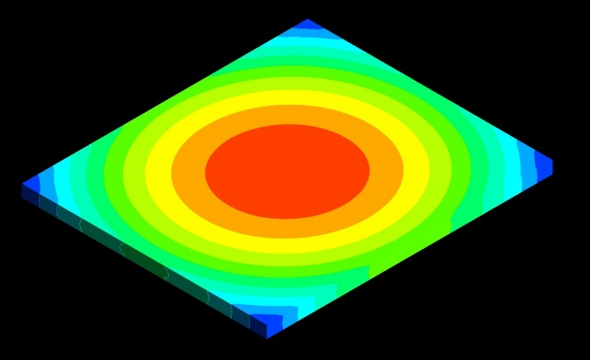
Figure 1. A sample figure.
Table 1. Change of data with respect to time.
Data | 1 h | 2 h | 3 h | 4 h | 5 h
A | 316 | 424 | 502 | 621 | 680
B | 452 | 501 | 518 | 630 | 701
If you need one column publishing for one of your figures to increase its visual quality, please add it in two column format first with a remark in the caption as follows. You should submit related figure separately.
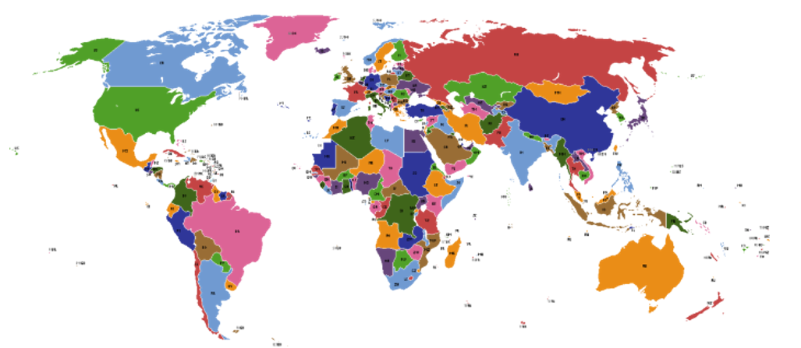
Figure 2. World map (It should be given in one column).
- Conclusion
You should submit a set of files containing your cover letter, table of contents entry (ToC) and manuscript. Figure and table lists are not mandatory to submit but, they should be submitted in cases which are defined in this guide. The Declaration of Competing Interest section should be shared as-given form below.
Declaration of Competing Interest
The authors declare that they have no known competing financial interests or personal relationships that could have appeared to influence the work reported in this paper.
Acknowledgement
If needed.
References
Font size should be 8 pt. in References section. All references should be showed in the text in brackets such as [1], [4-8] etc. IEEE (the Institute of Electrical and Electronics Engineers) referencing style is only accepted referencing format for BMSM. For further details on IEEE referencing style please see:
https://ieeeauthorcenter.ieee.org/wp-content/uploads/IEEE-Reference-Guide.pdf
[1] …
[2] …

